Metrics and Visualizations Report

Core Concepts
Code generation, Computer programming, Programming, Software development, Software engineering, Source code

Visualizations
trend_raw_Avg_Pairwise_Sim.png
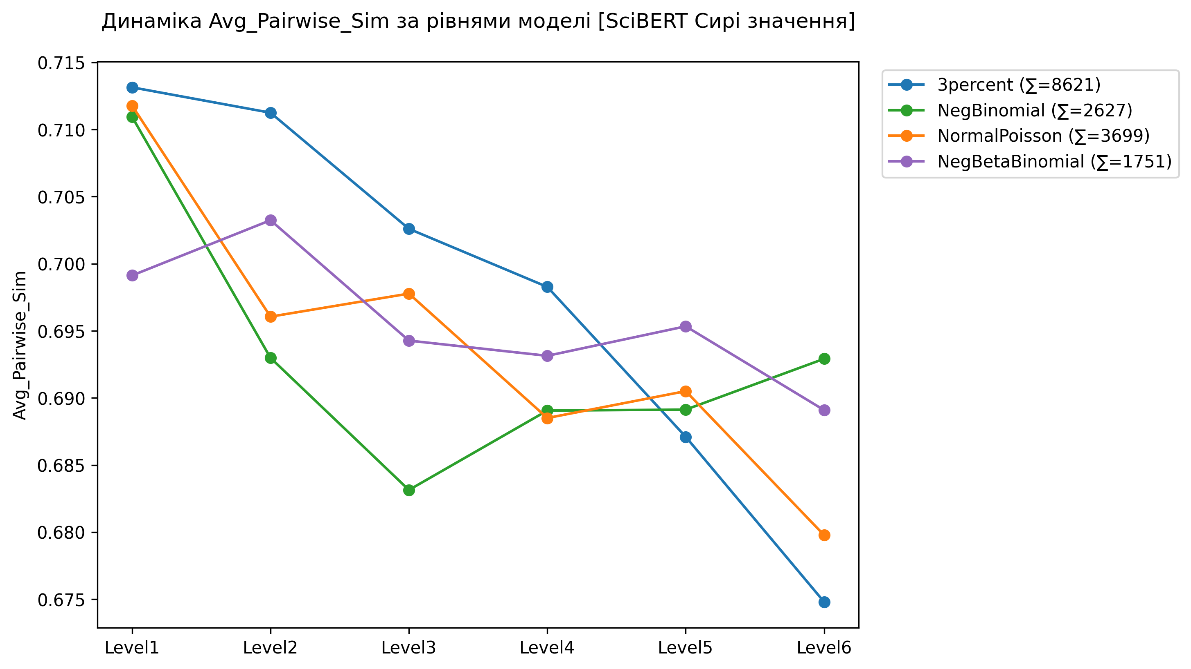
trend_raw_Semantic_Drift.png
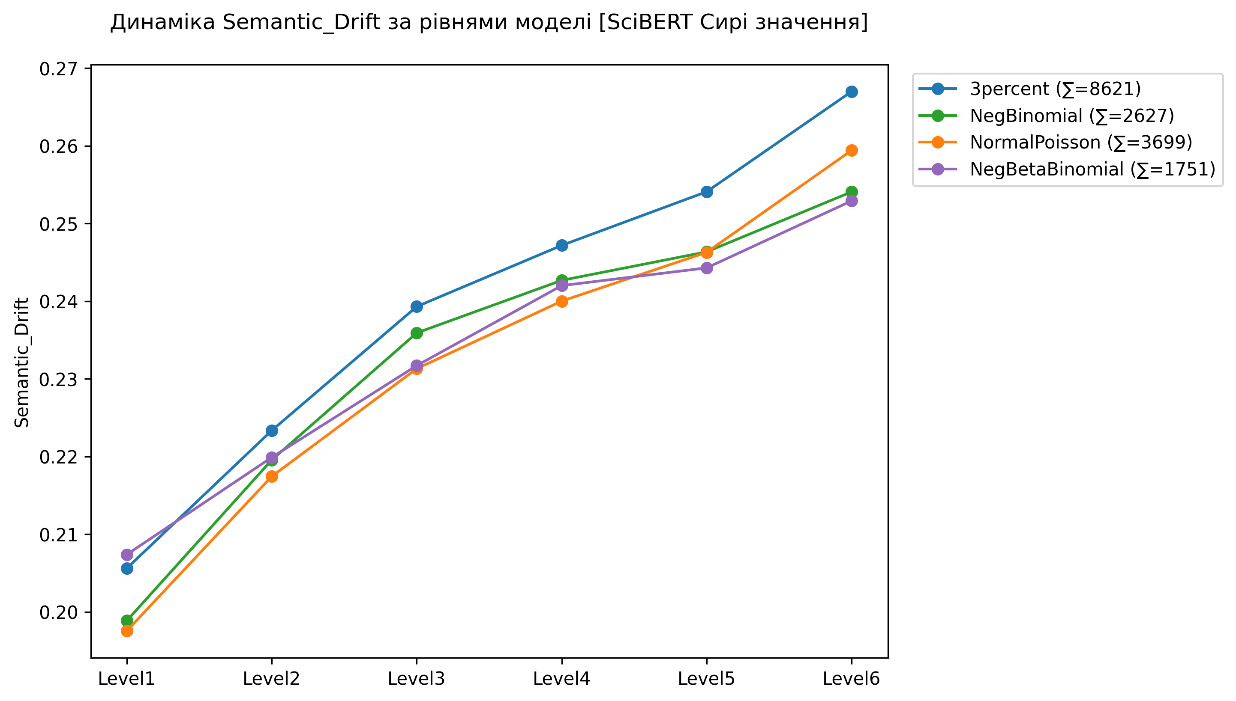
trend_raw_Core_Proximity_%.png
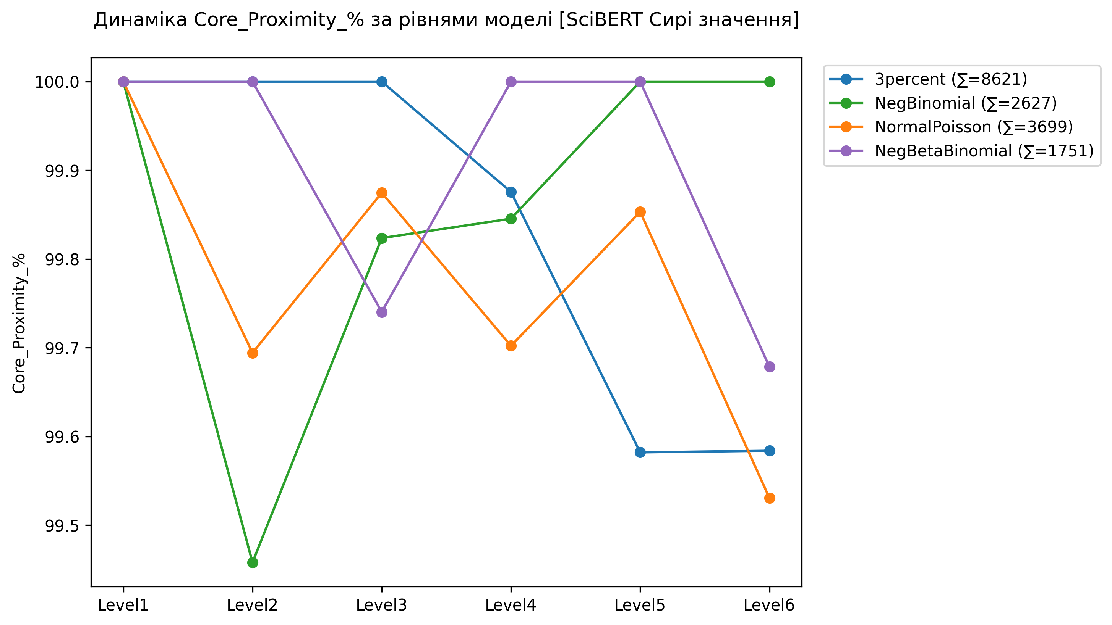
trend_raw_Diversity.png
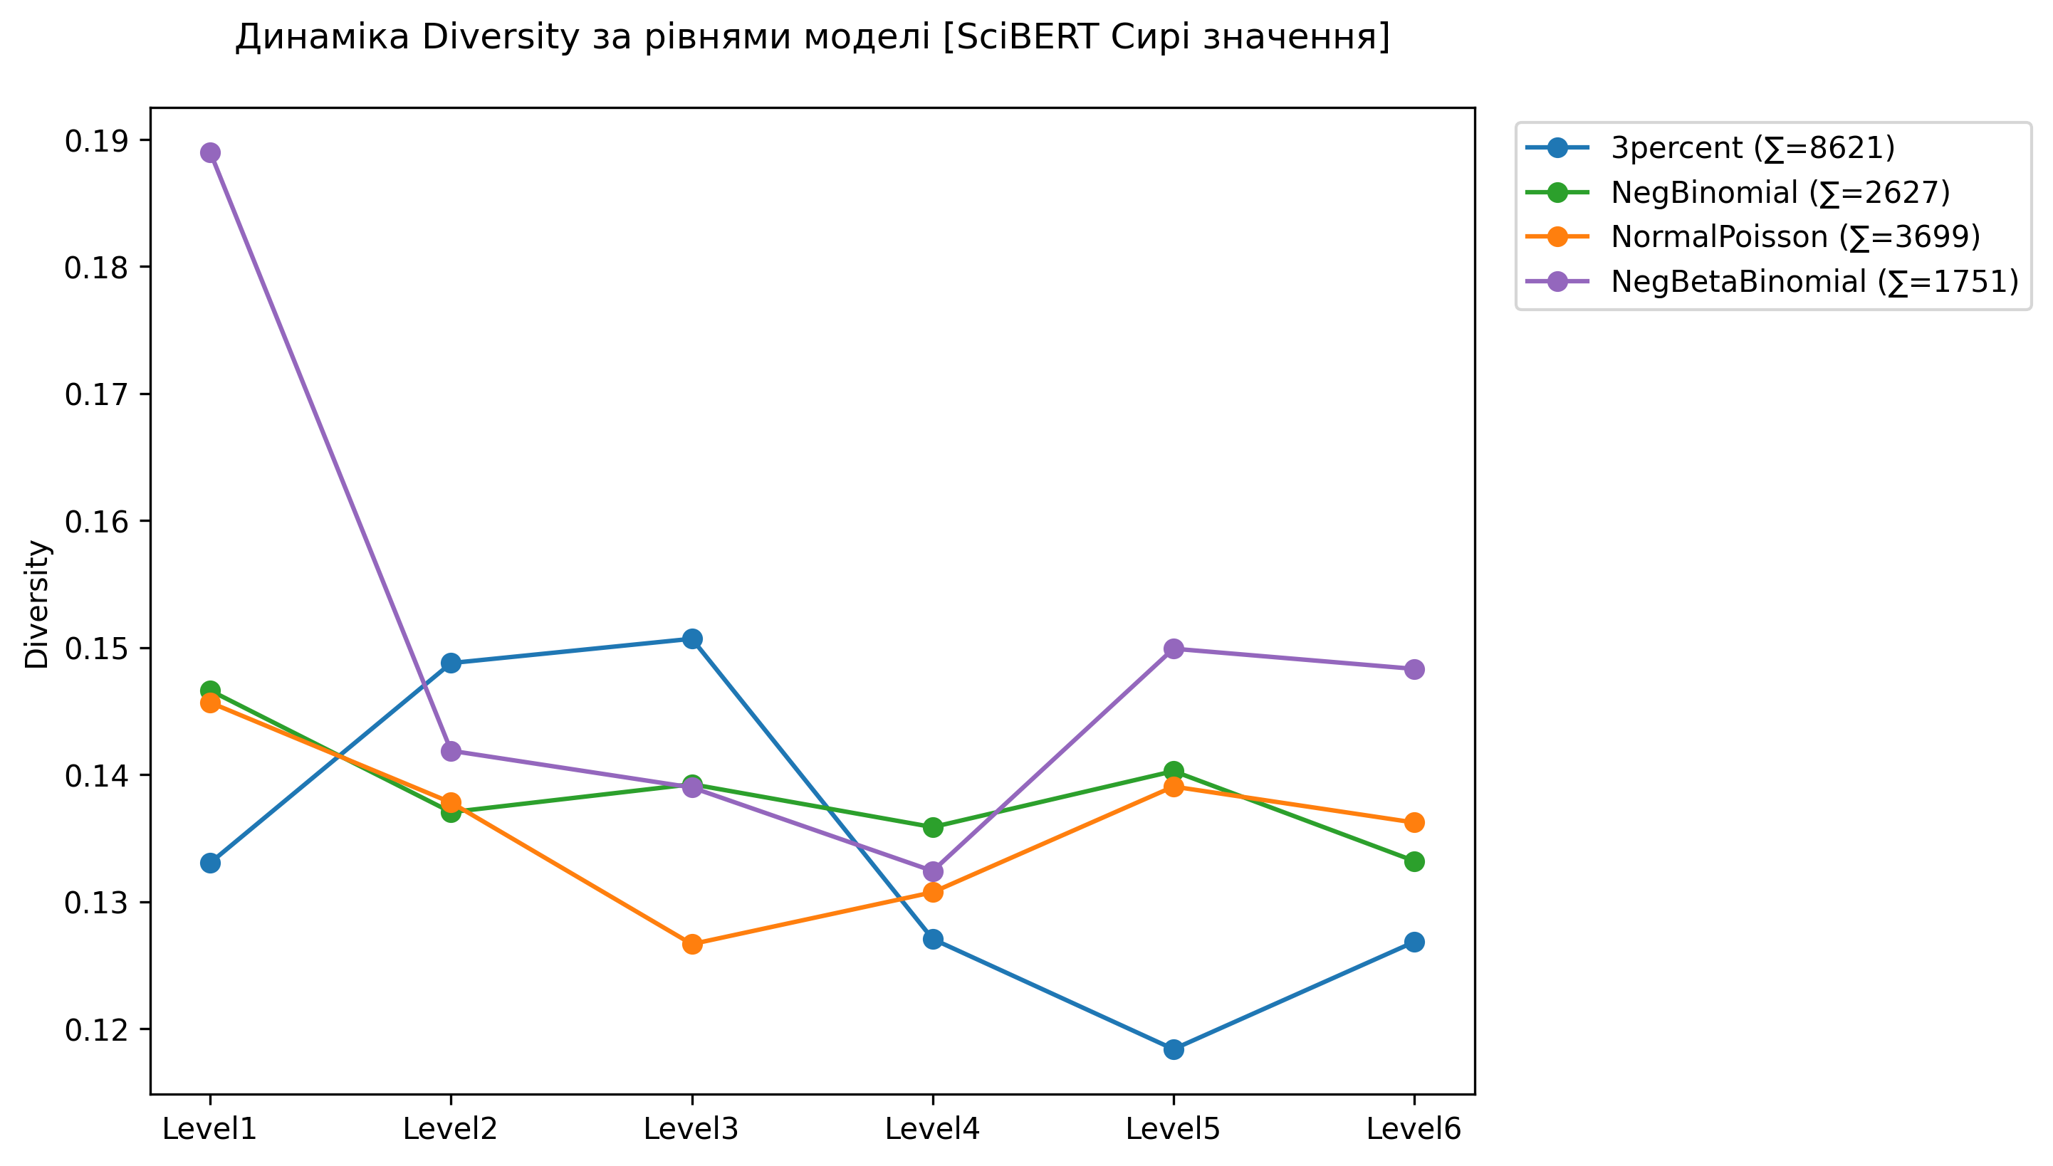
trend_raw_Topical_Diversity_Entropy.png
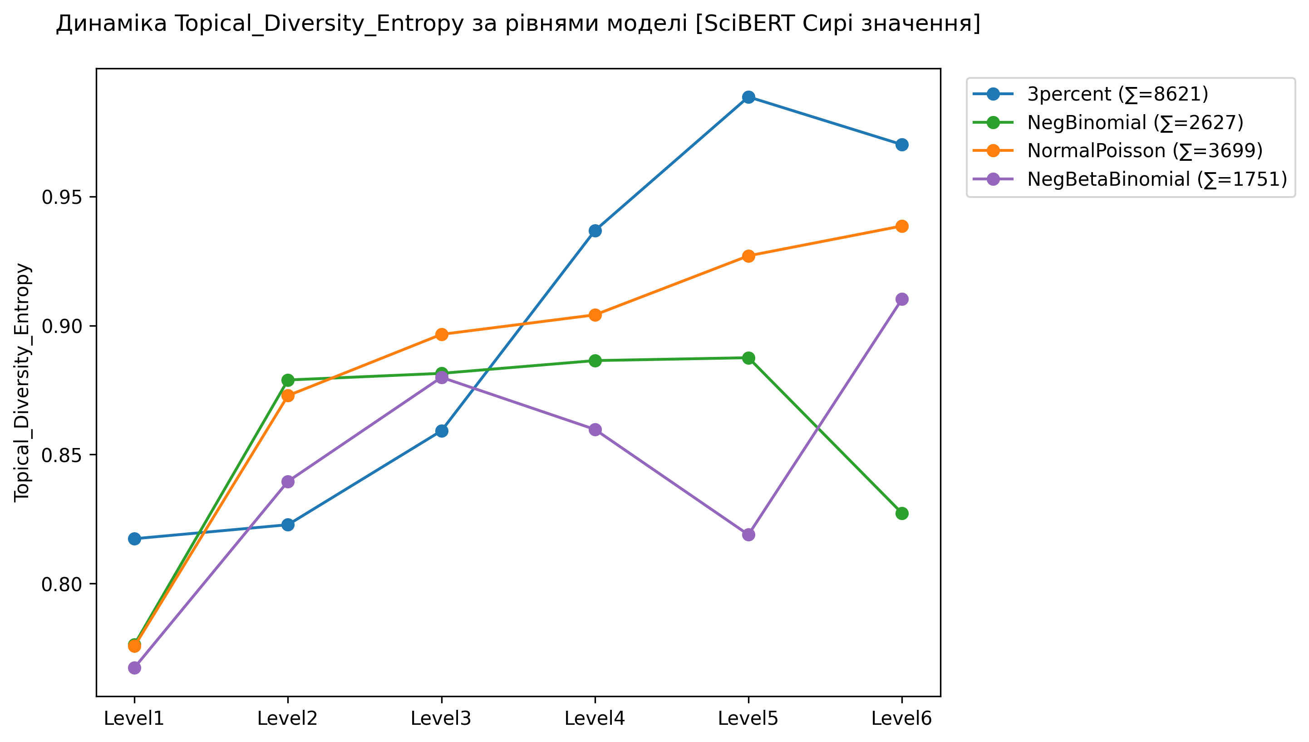
radar_3percent.png
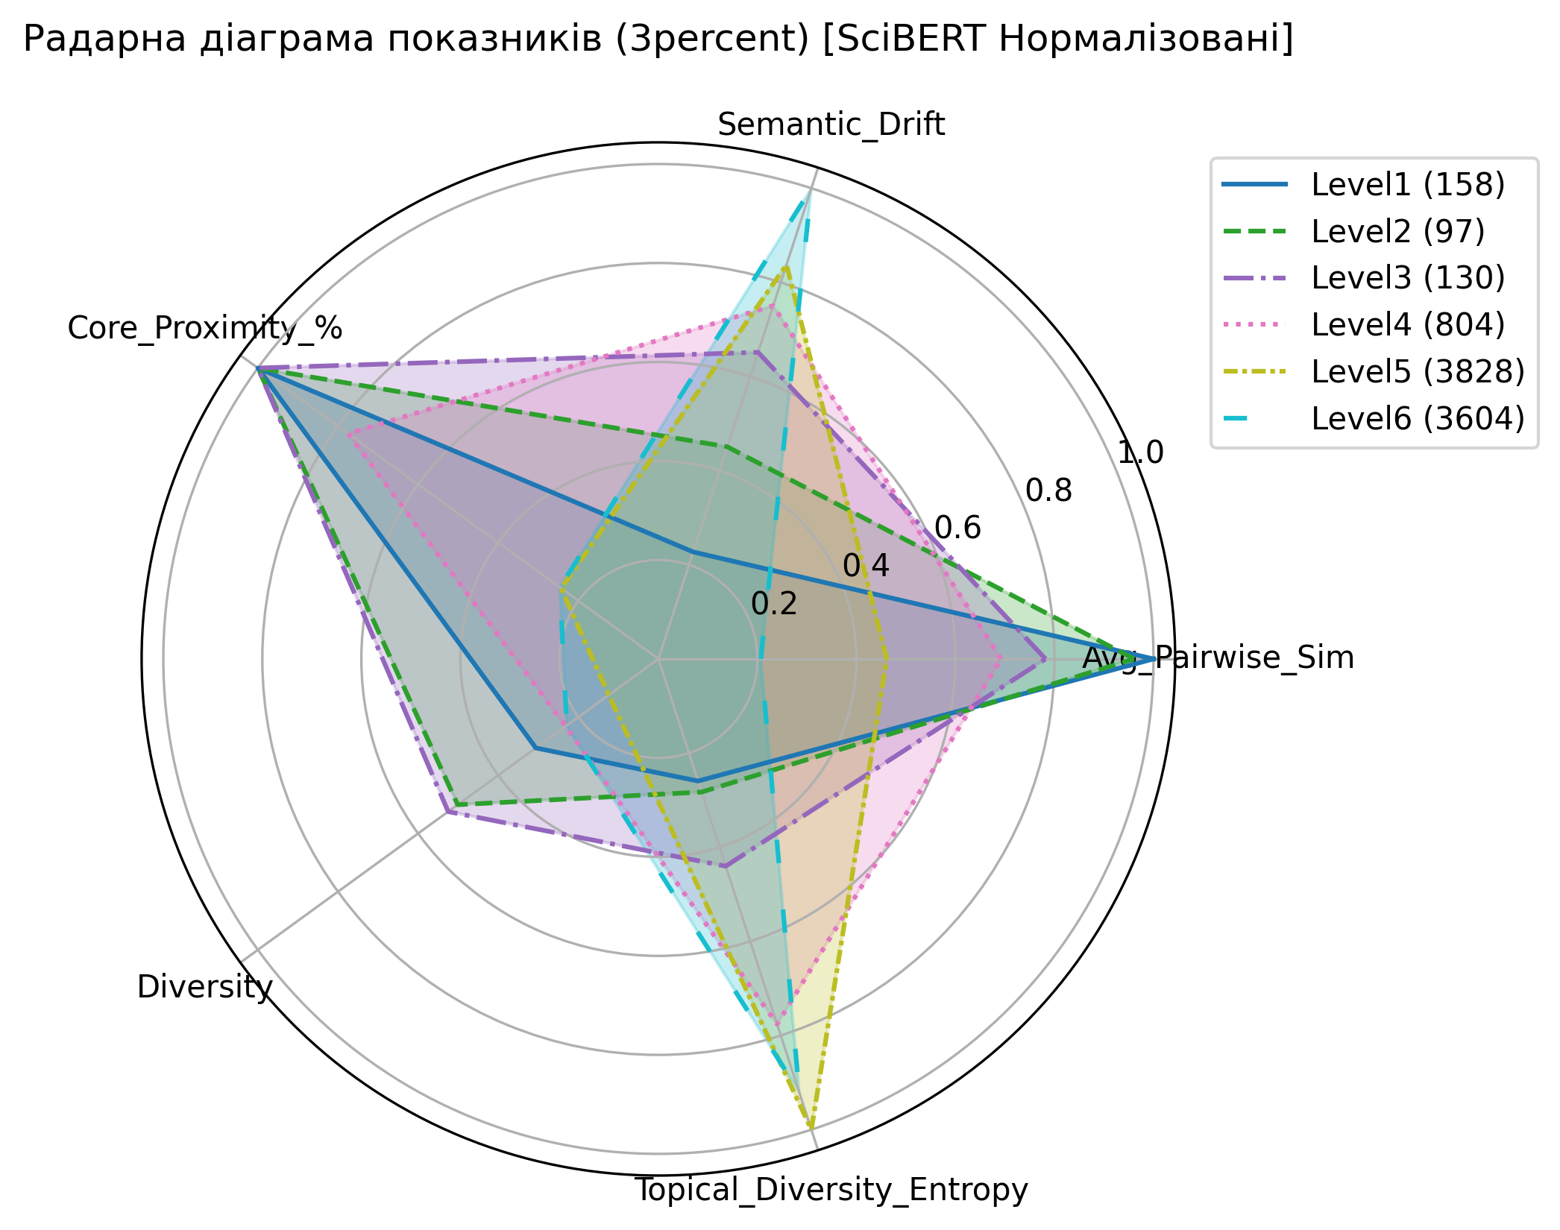
radar_NegBinomial.png
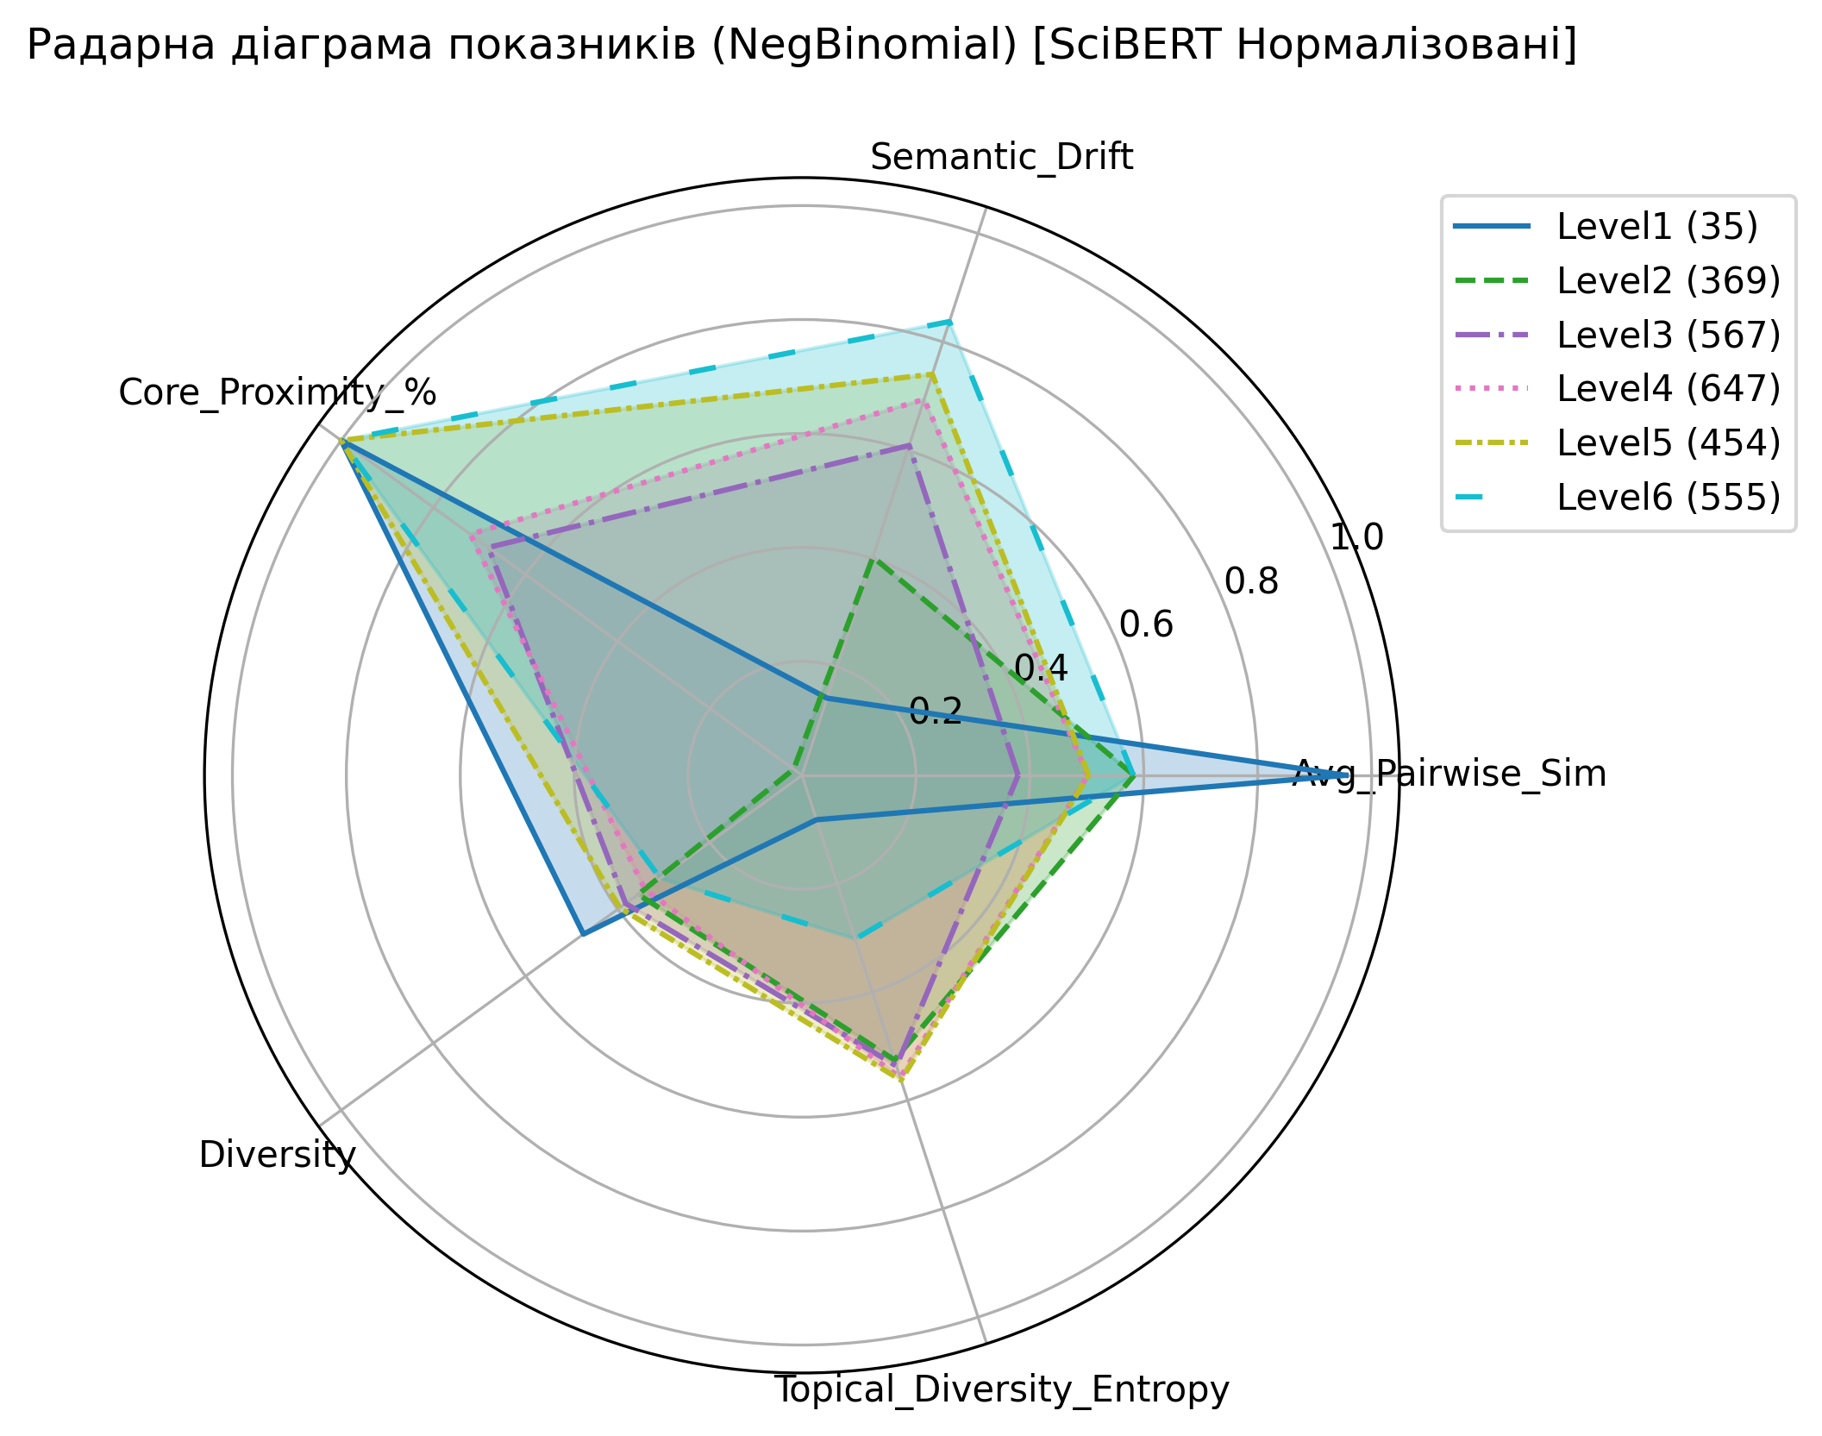
radar_NormalPoisson.png
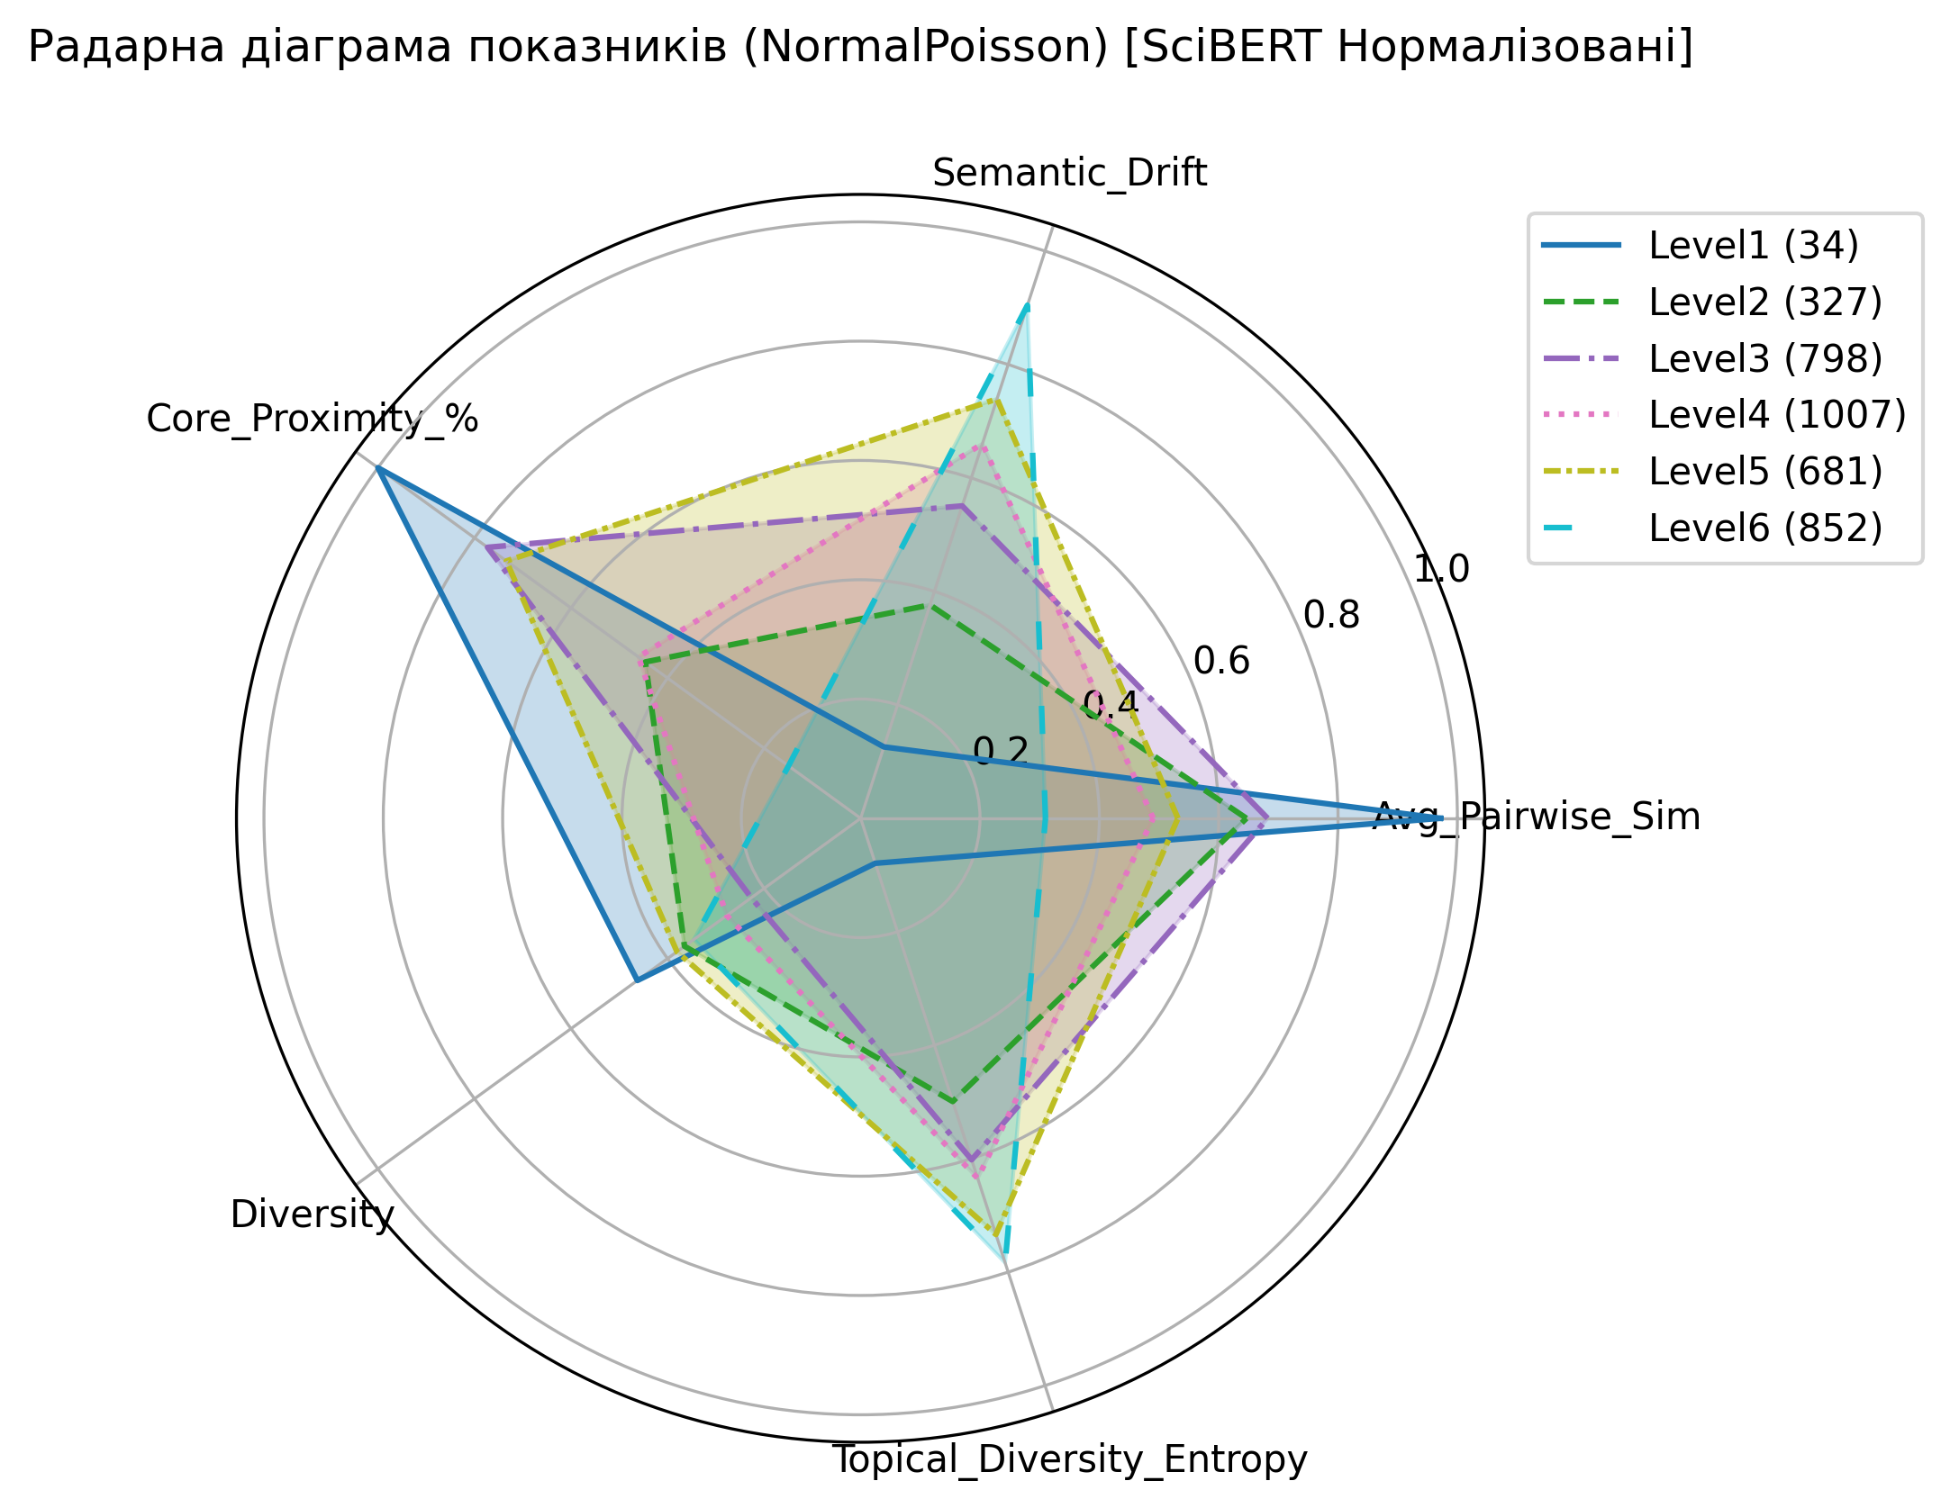
radar_NegBetaBinomial.png
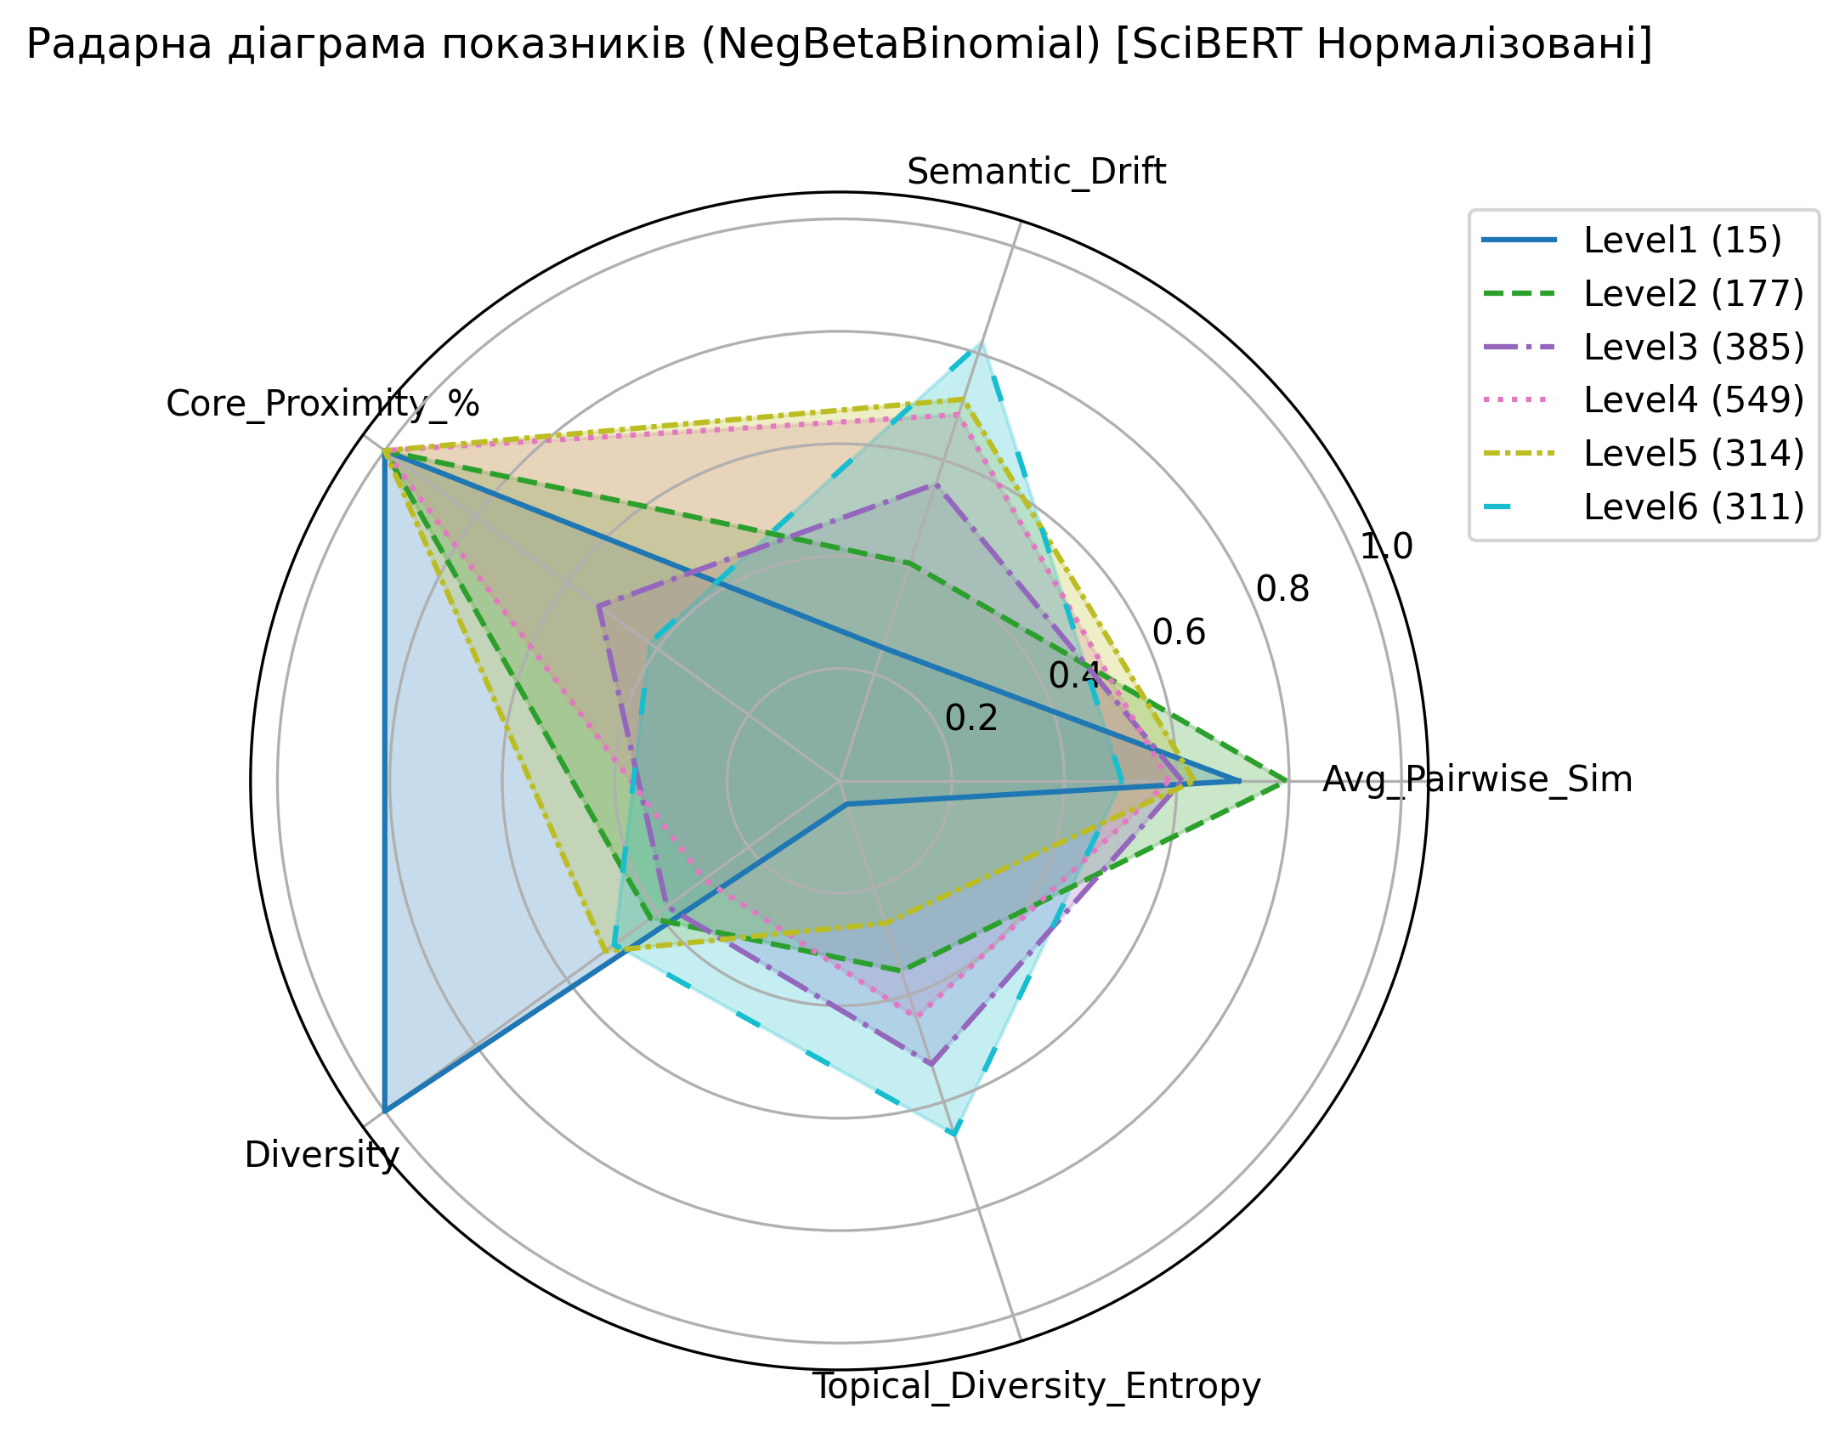
topical_diversity_entropy_heatmap.png
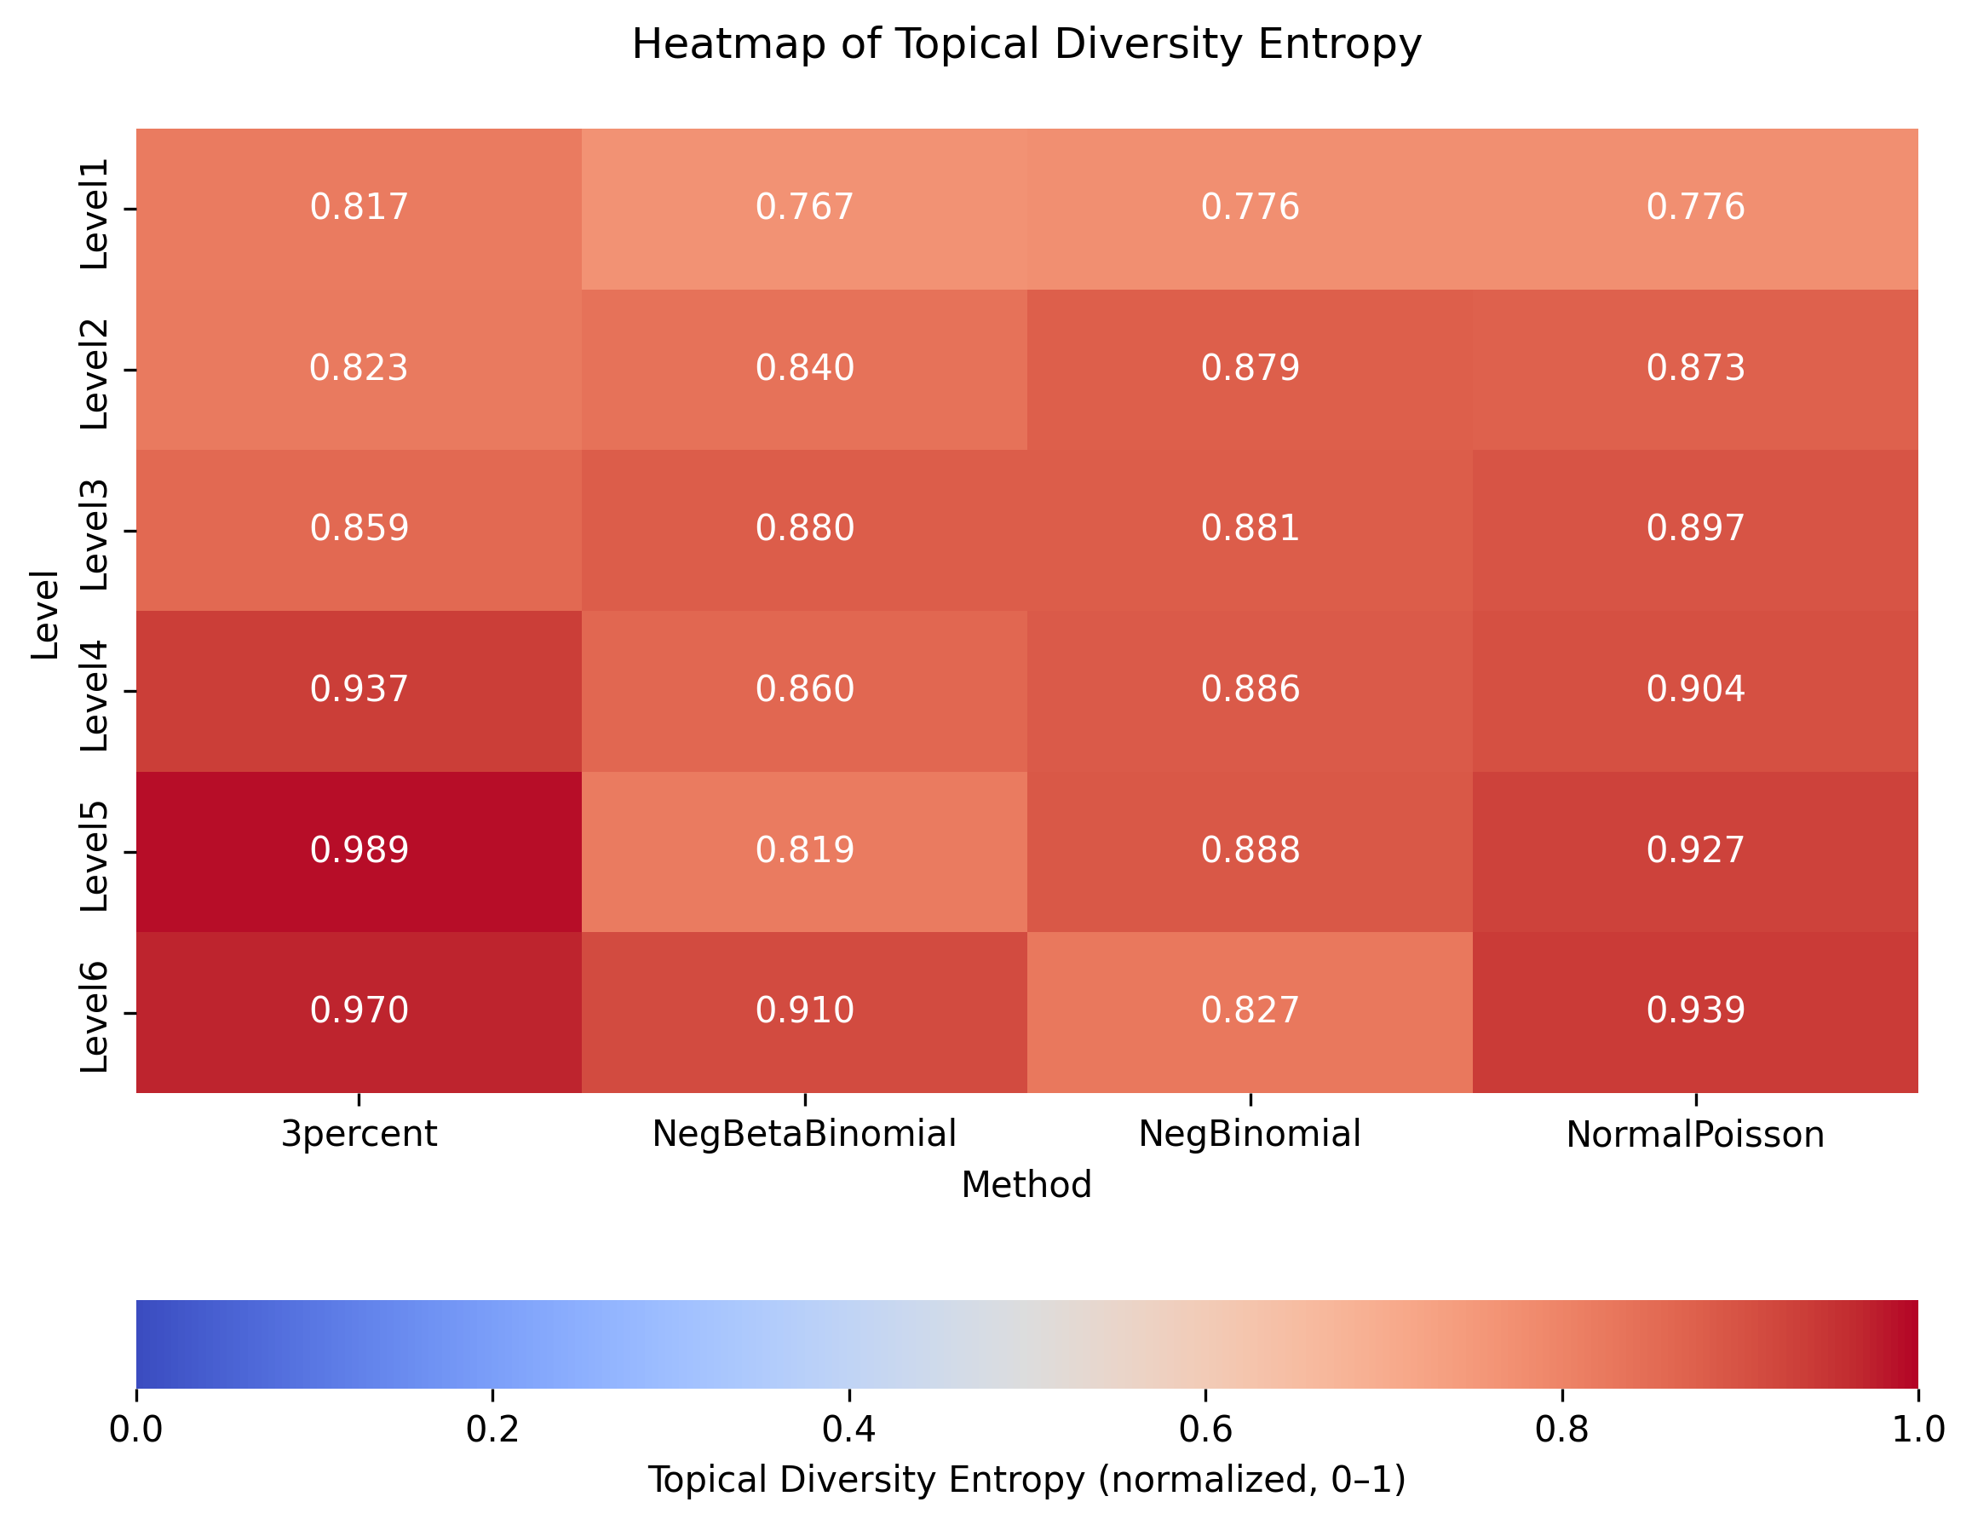
concept_counts_log.png
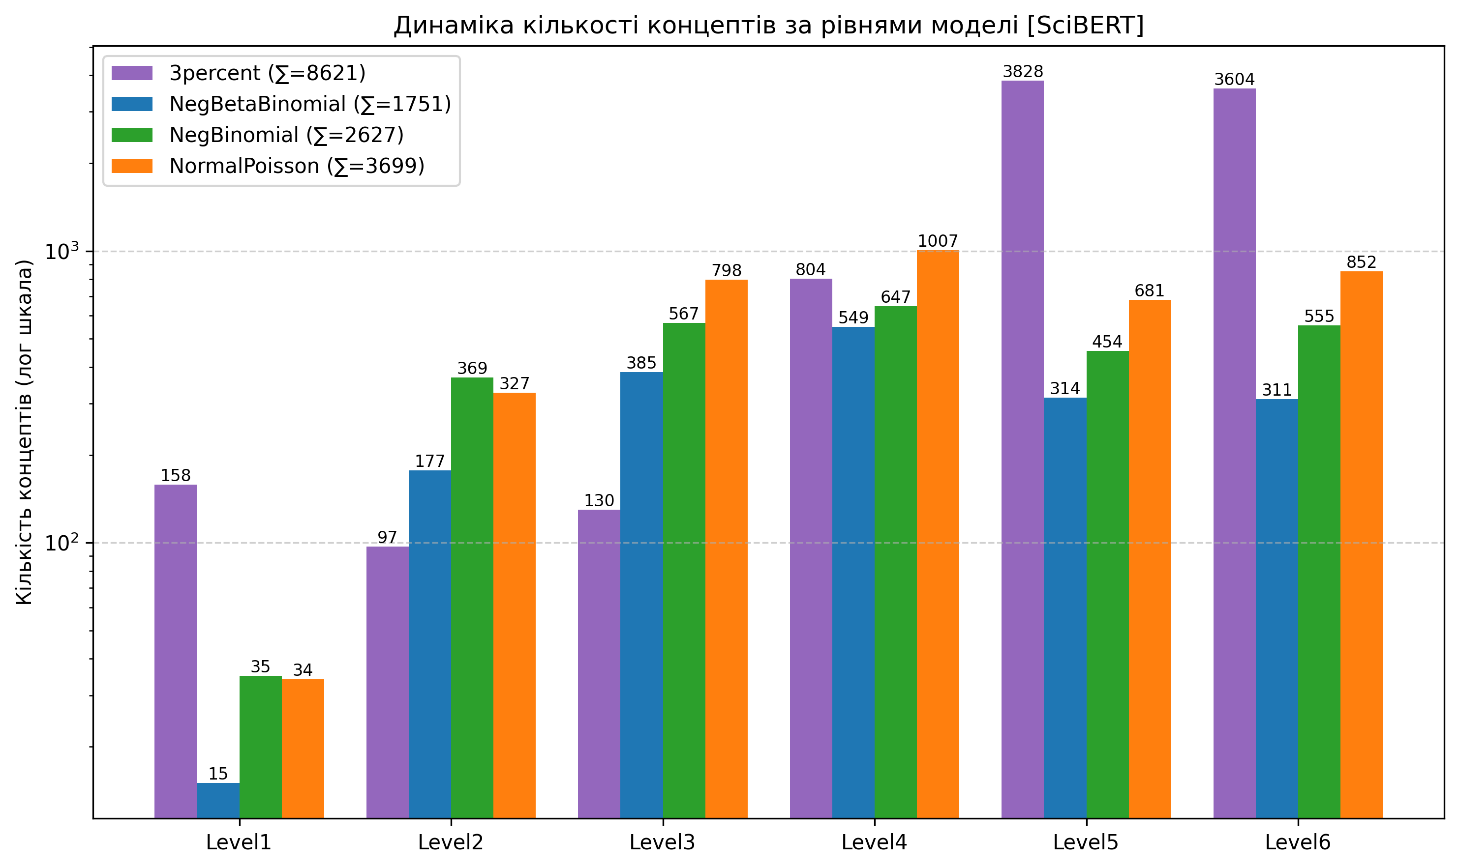
pca_3percent.png
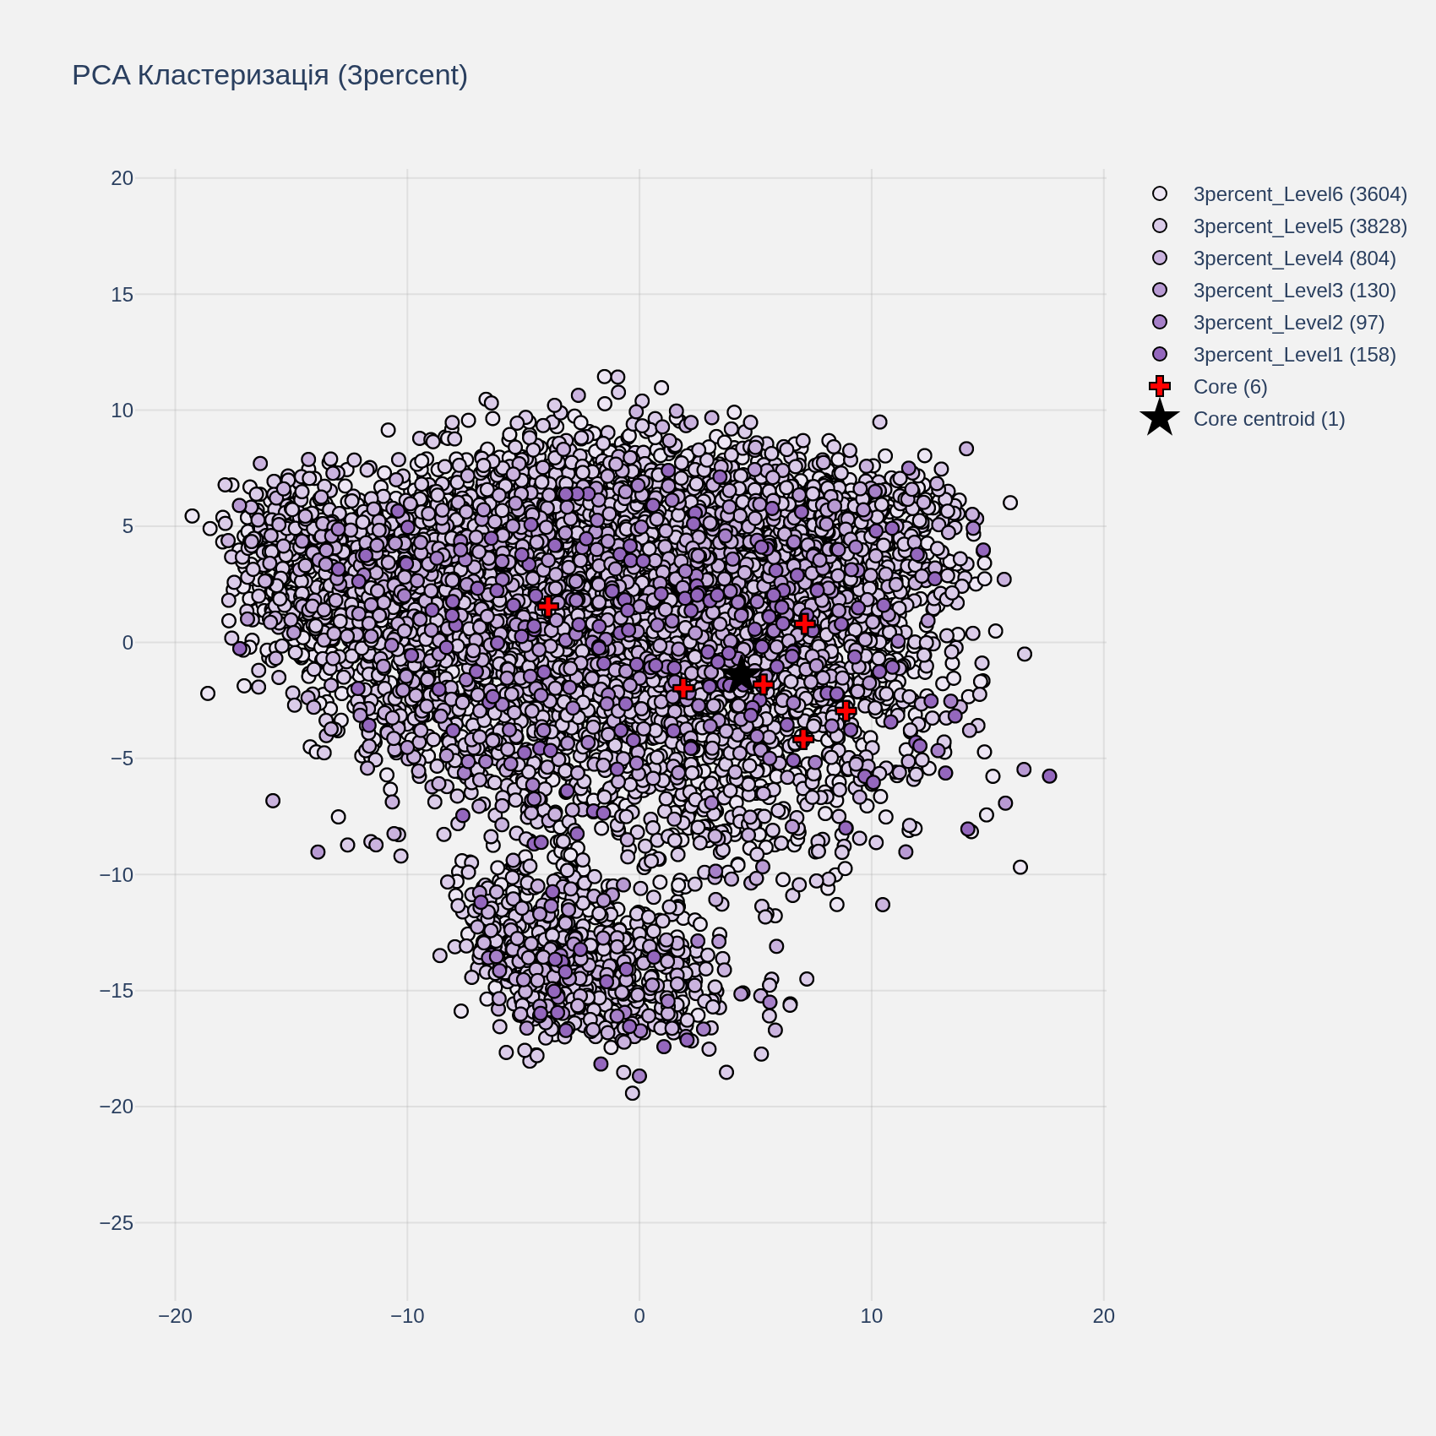
pca_NegBinomial.png
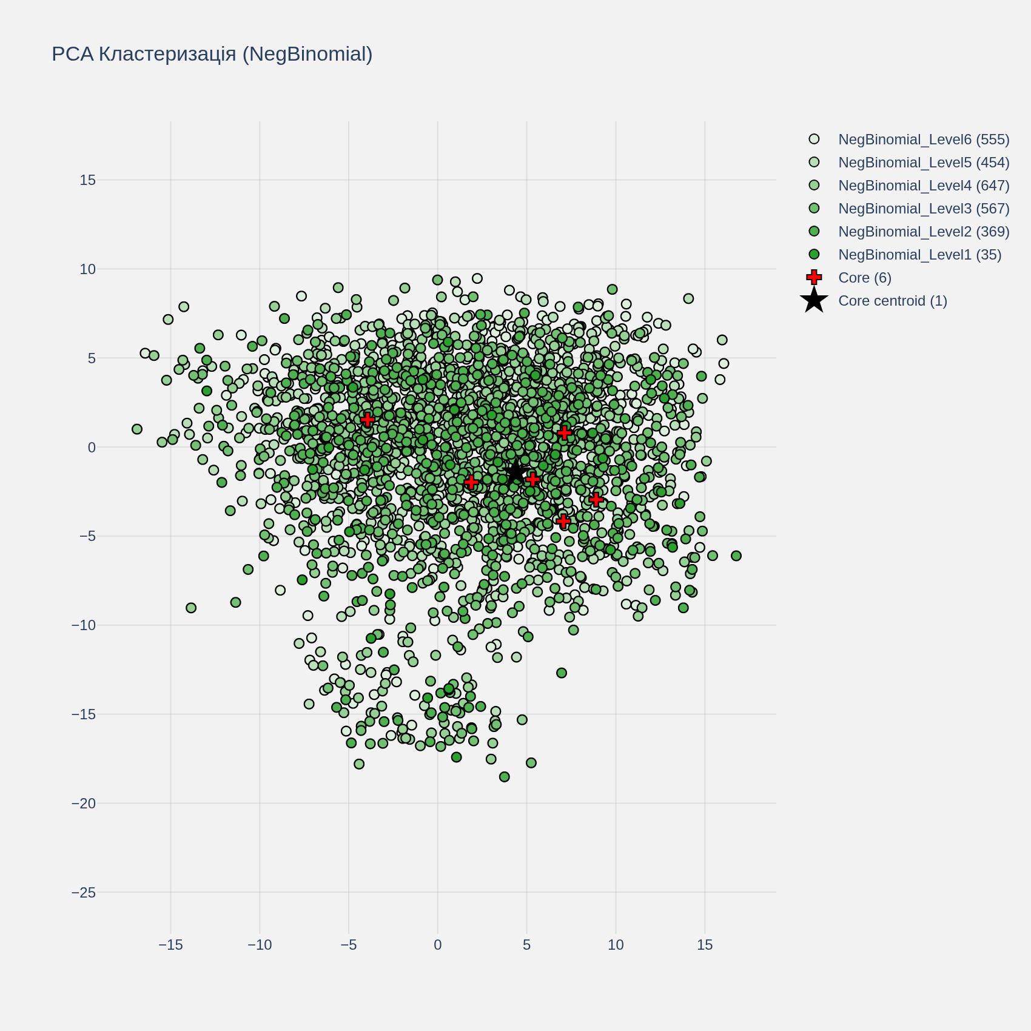
pca_NormalPoisson.png
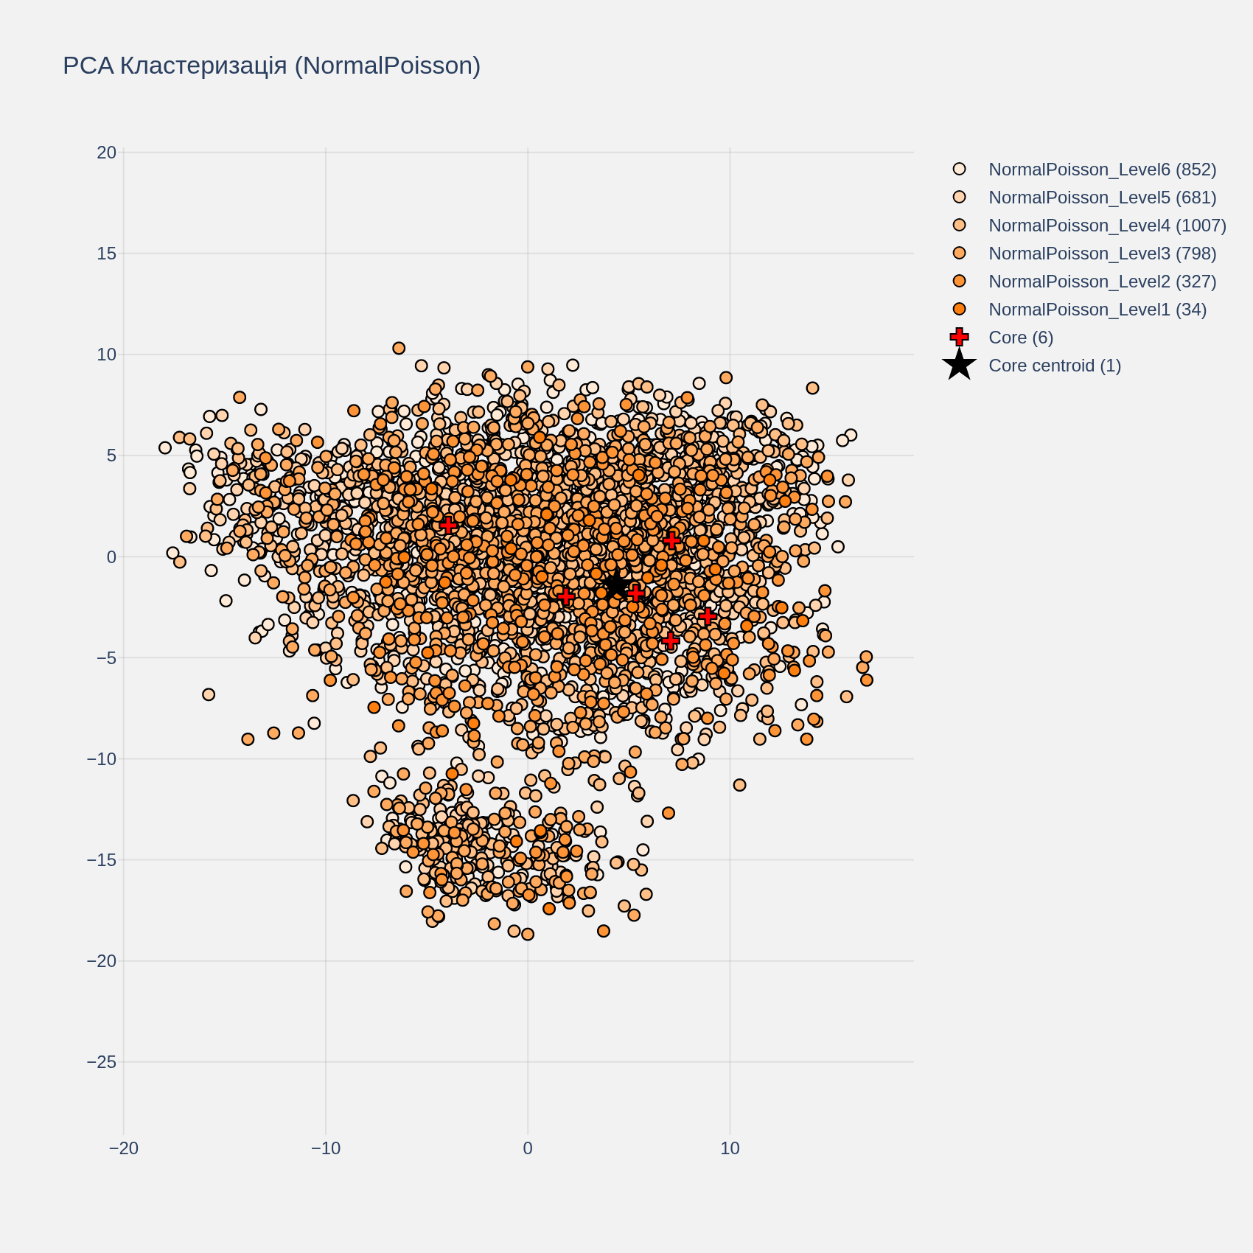
pca_NegBetaBinomial.png
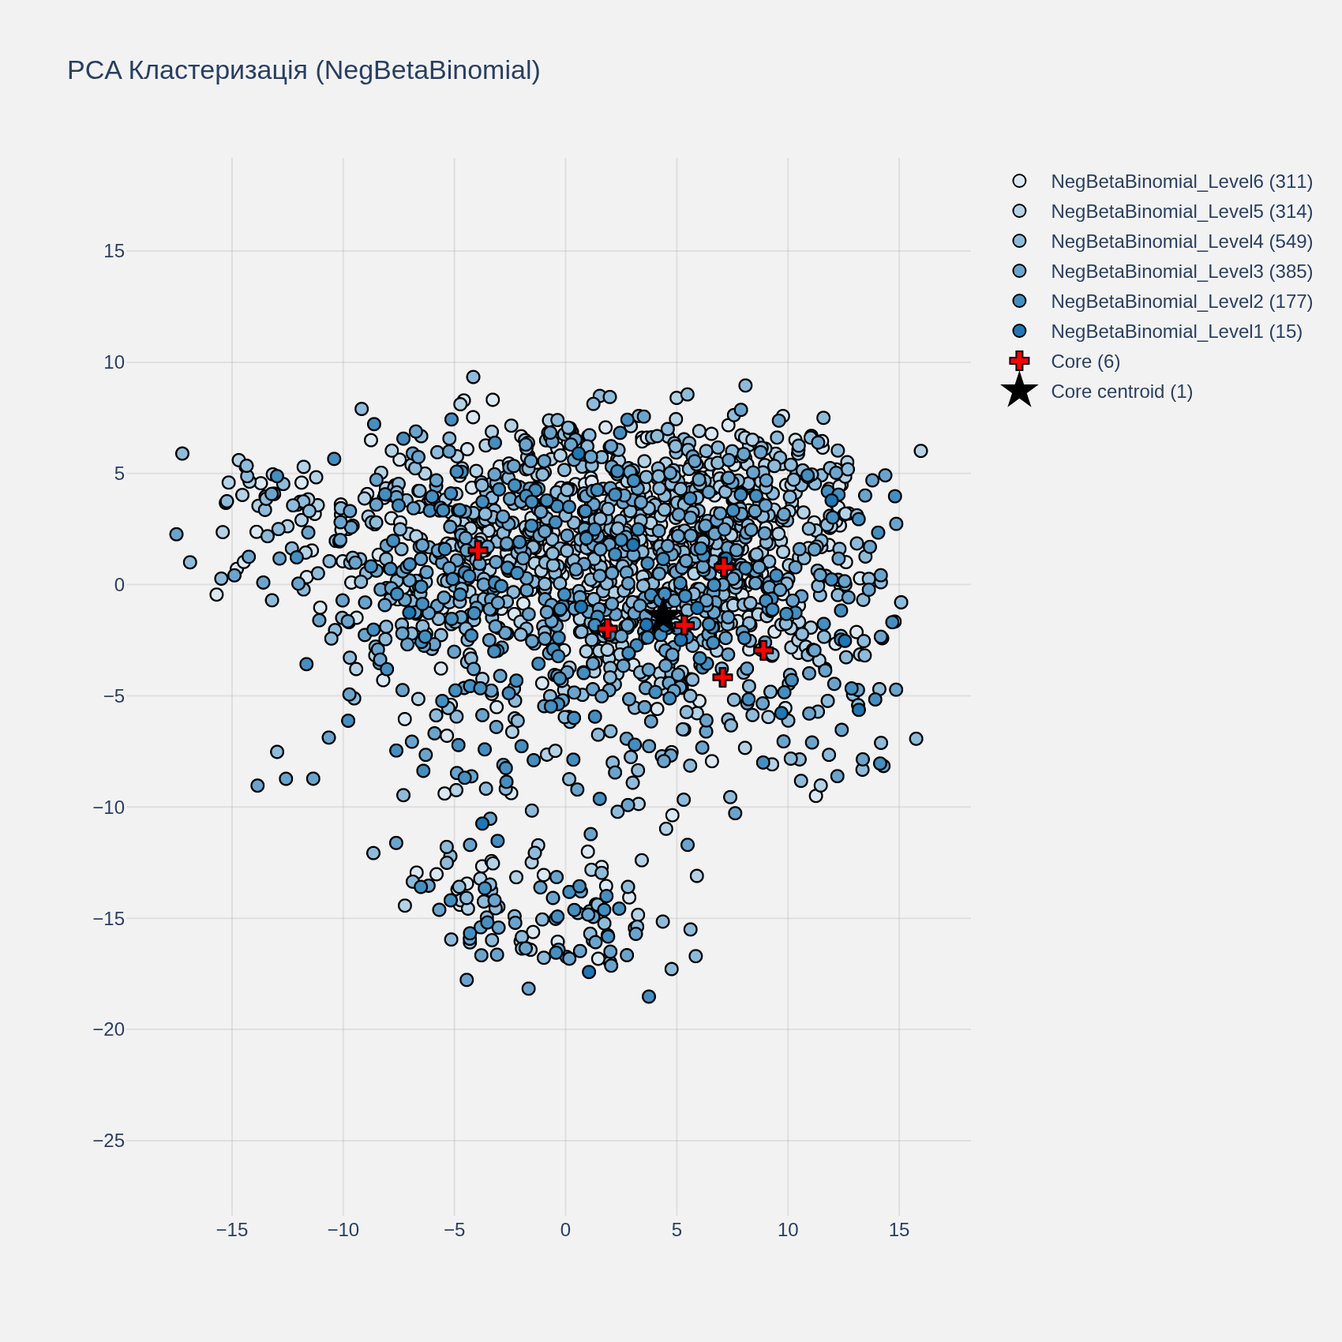
pca_combined.png
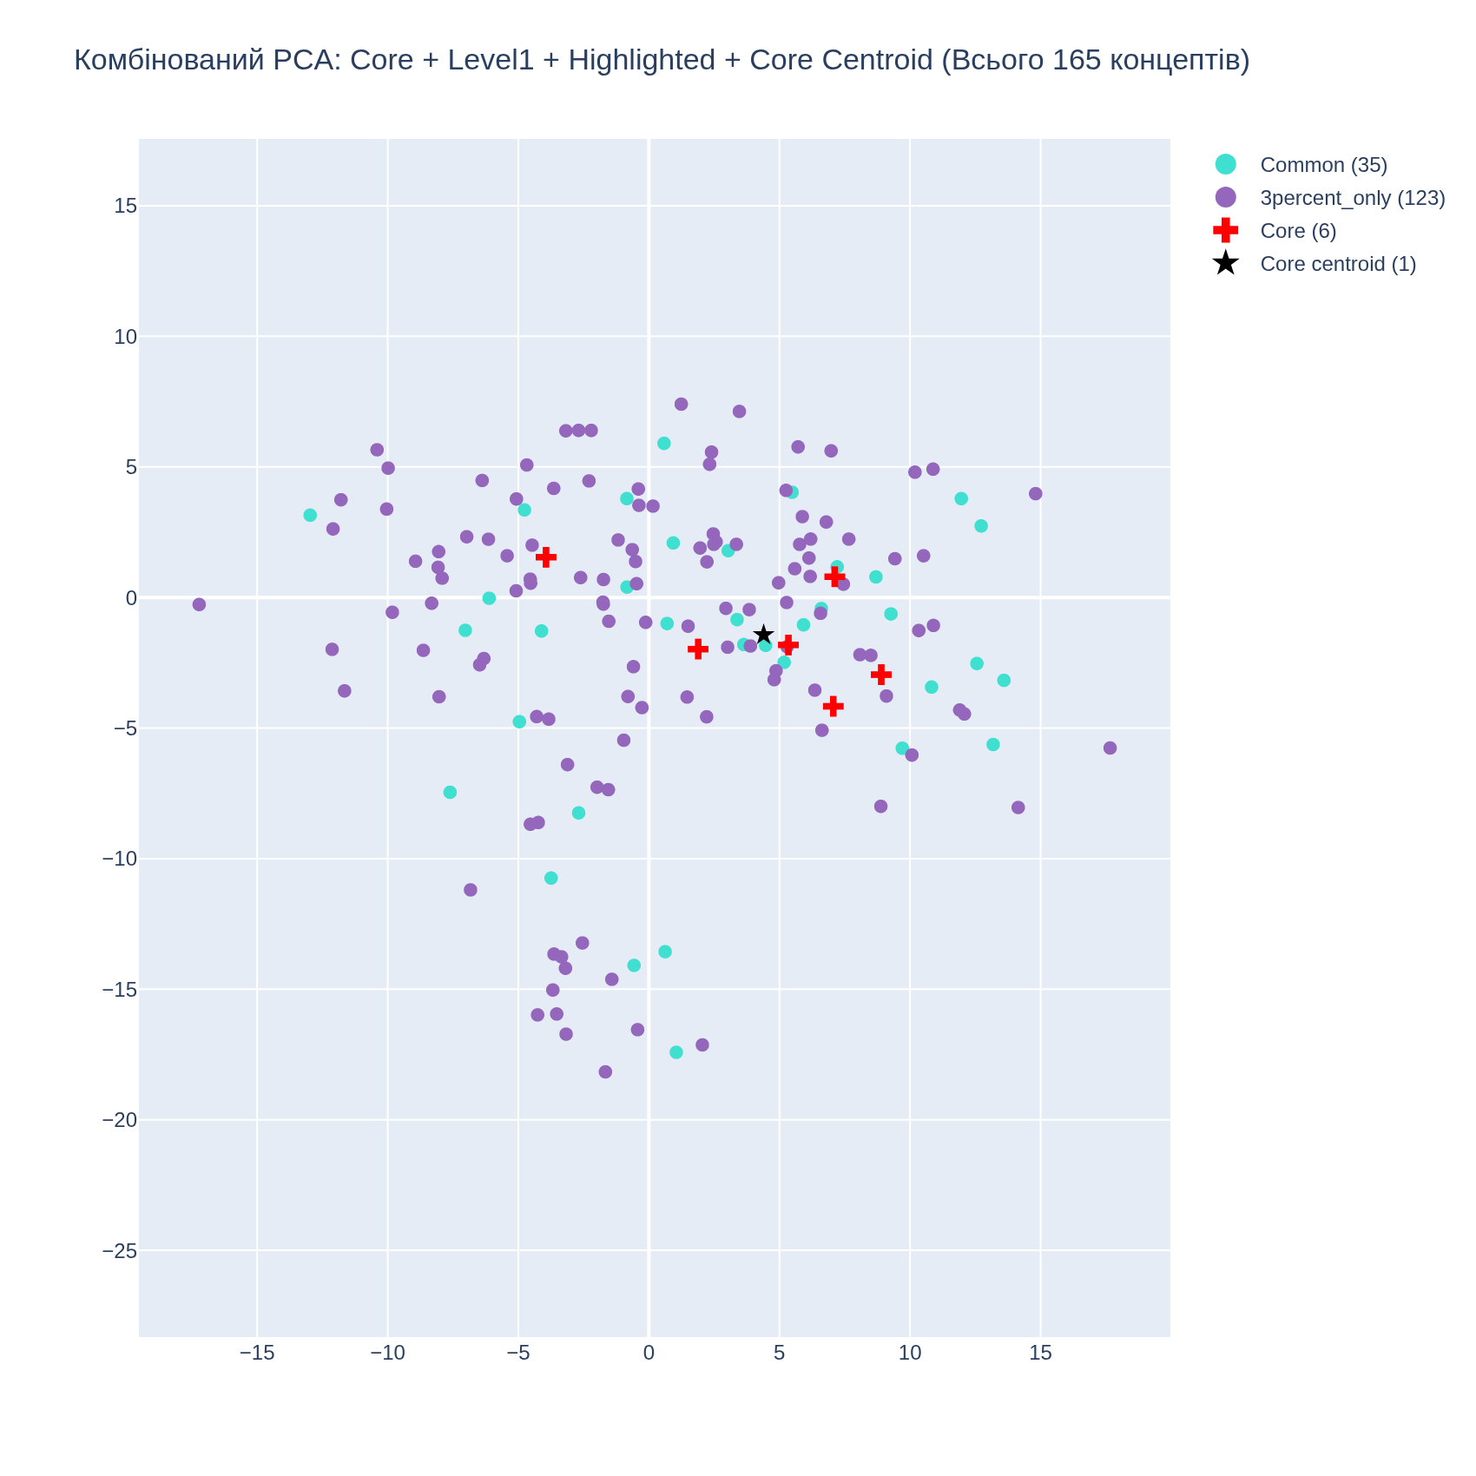
alignment_scores.png
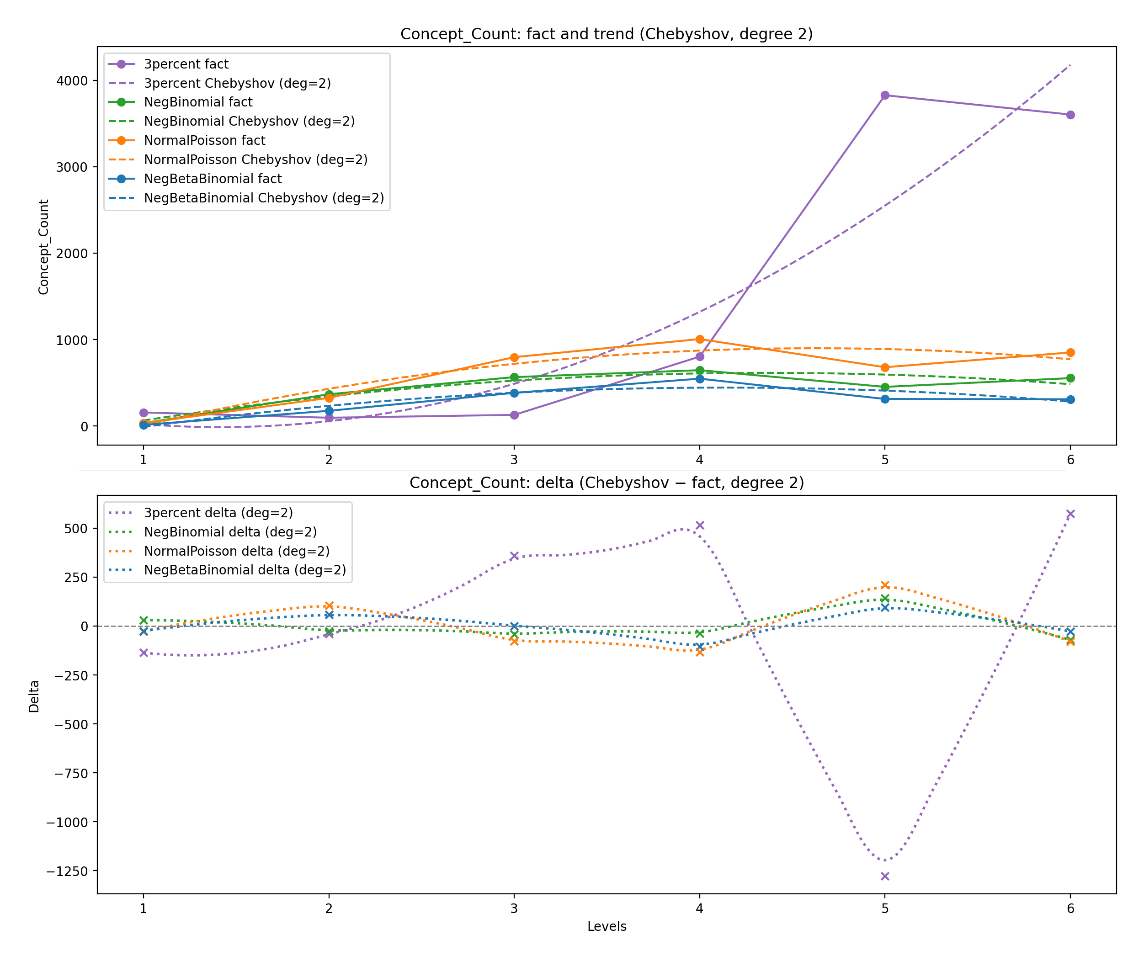
deltas_Avg_Pairwise_Sim_two_panels_deg2.png
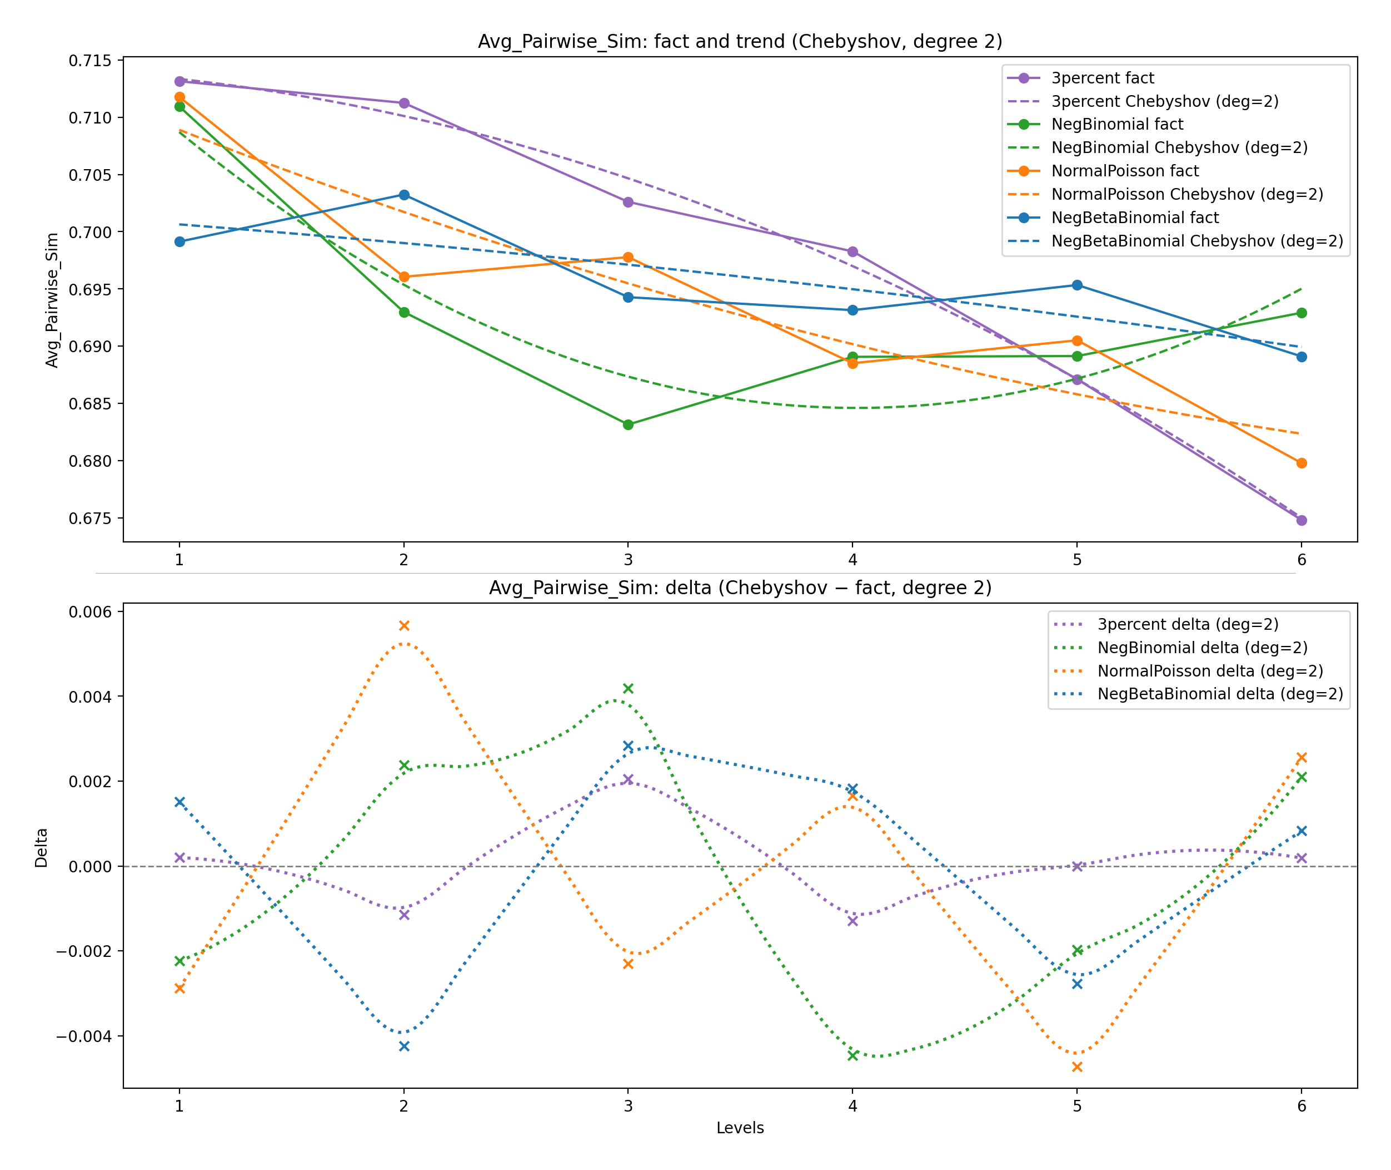
deltas_Semantic_Drift_two_panels_deg2.png
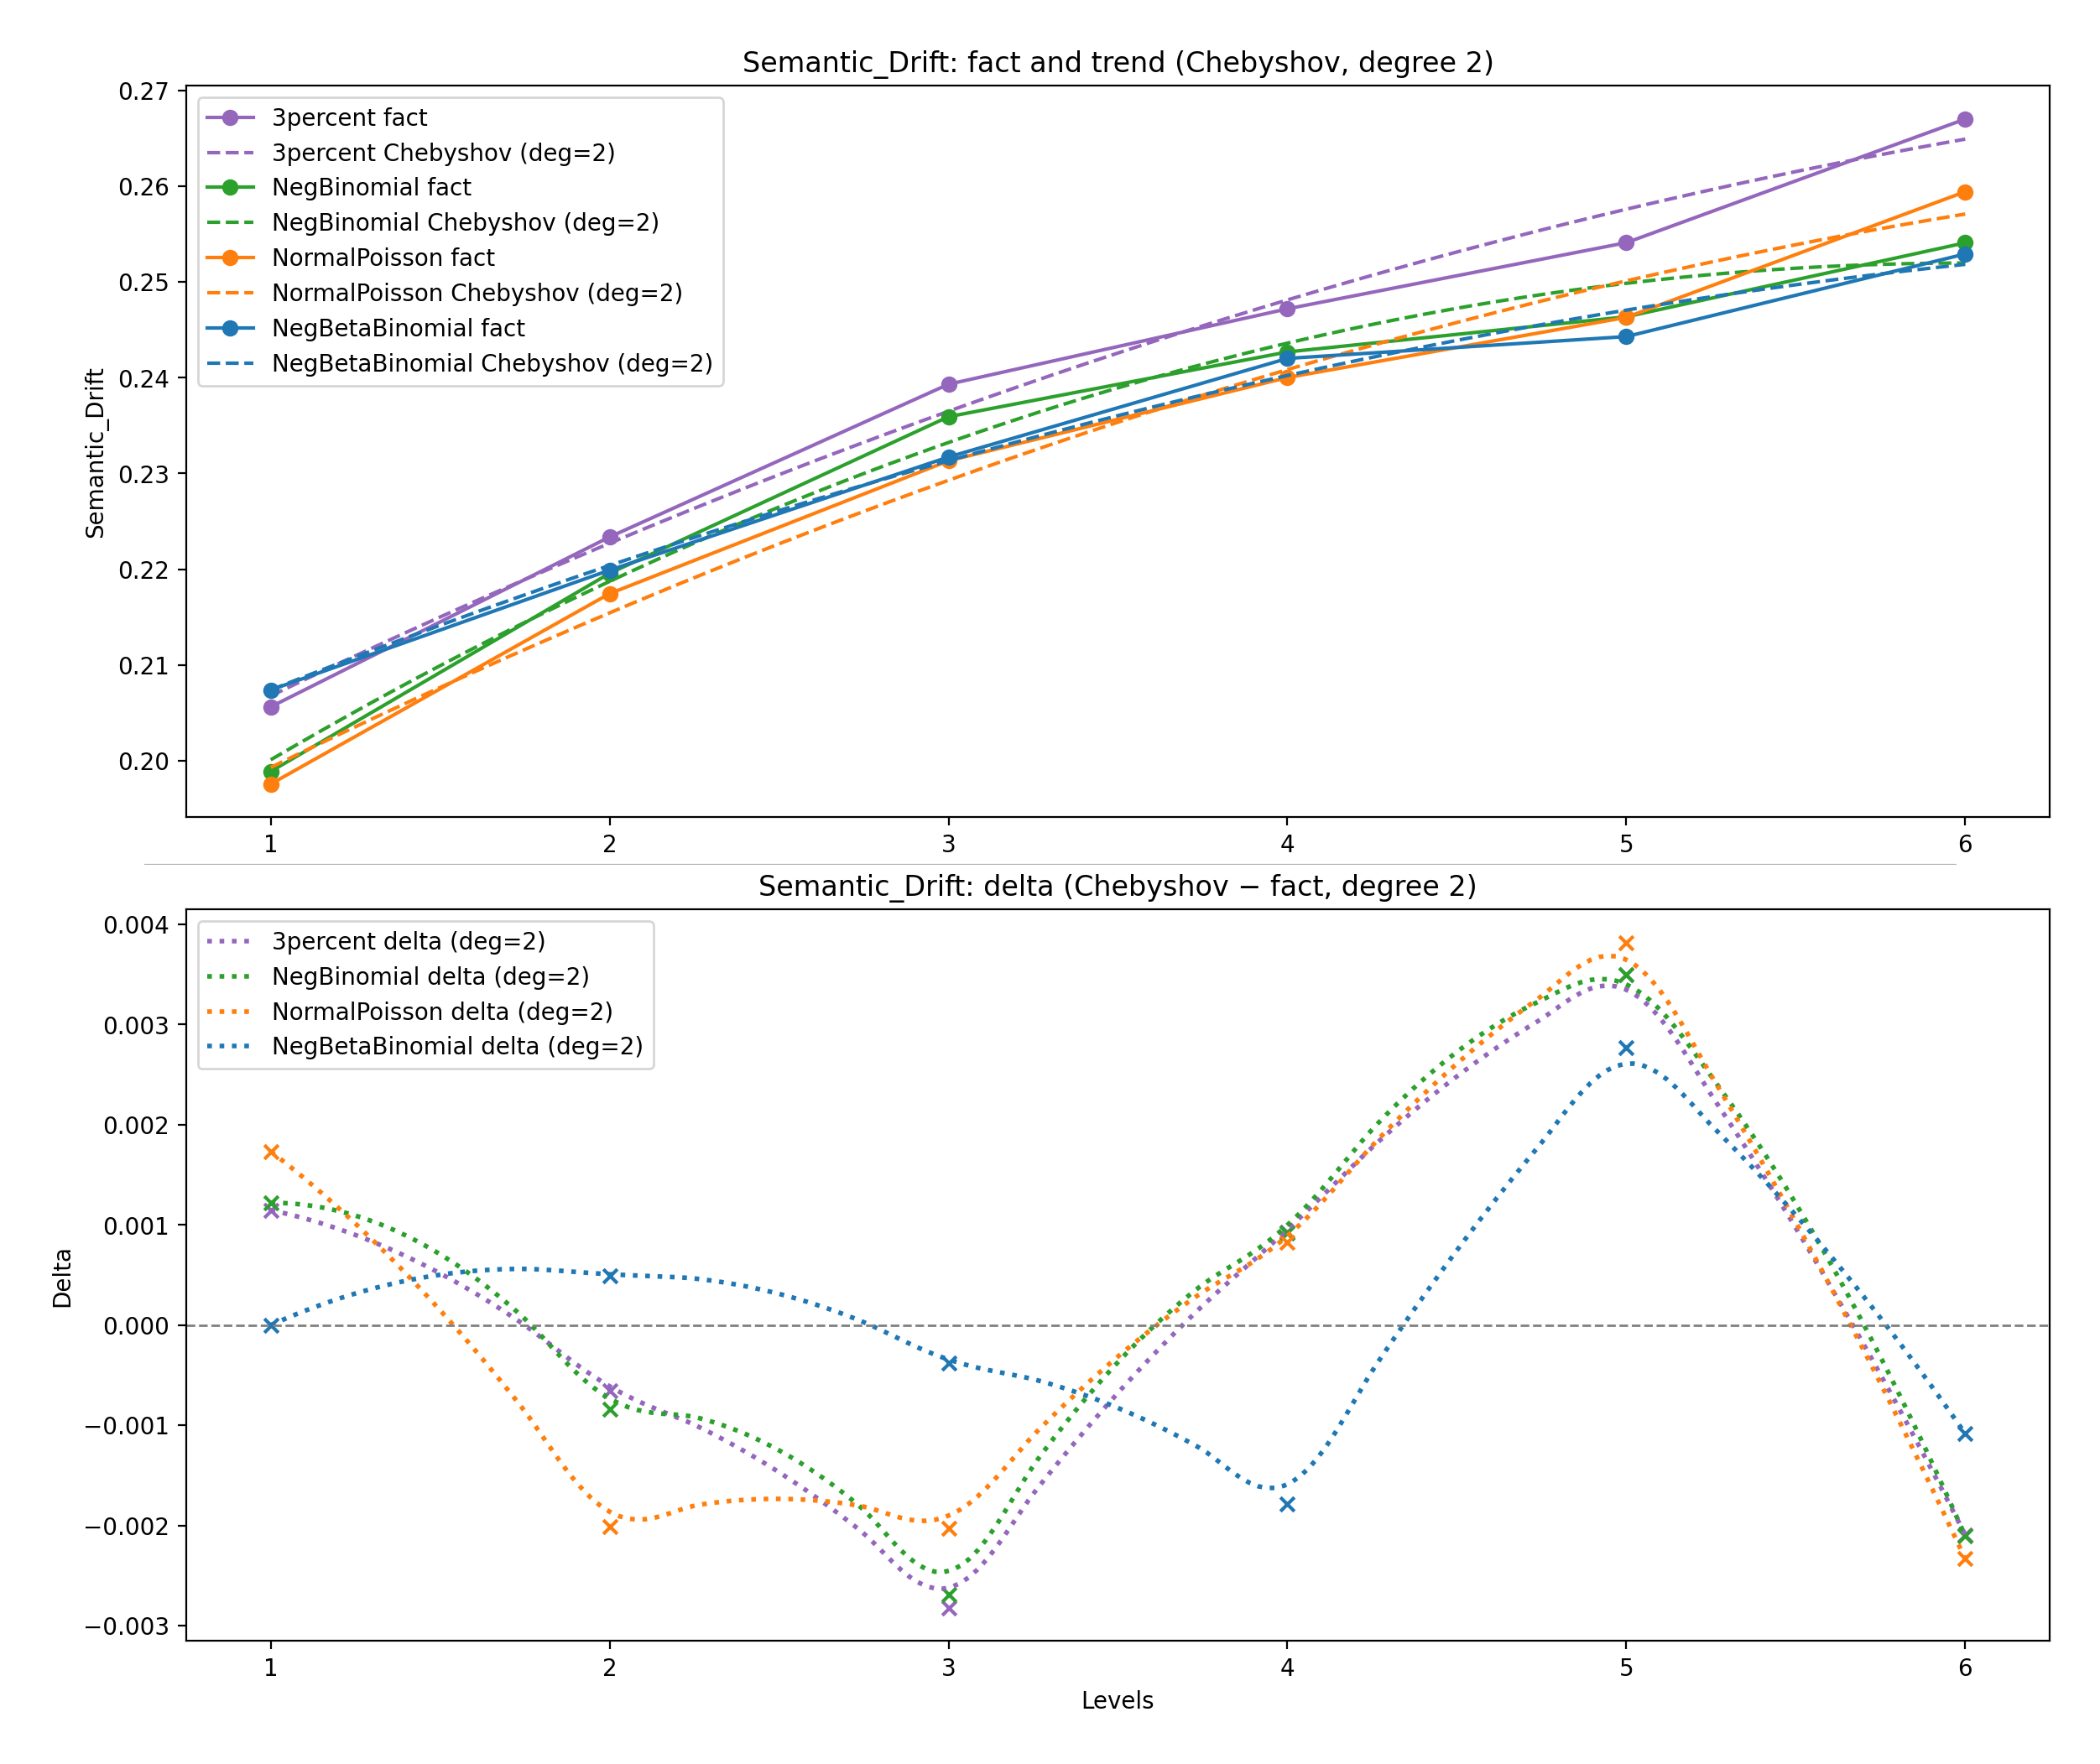
deltas_Core_Proximity_%_two_panels_deg2.png
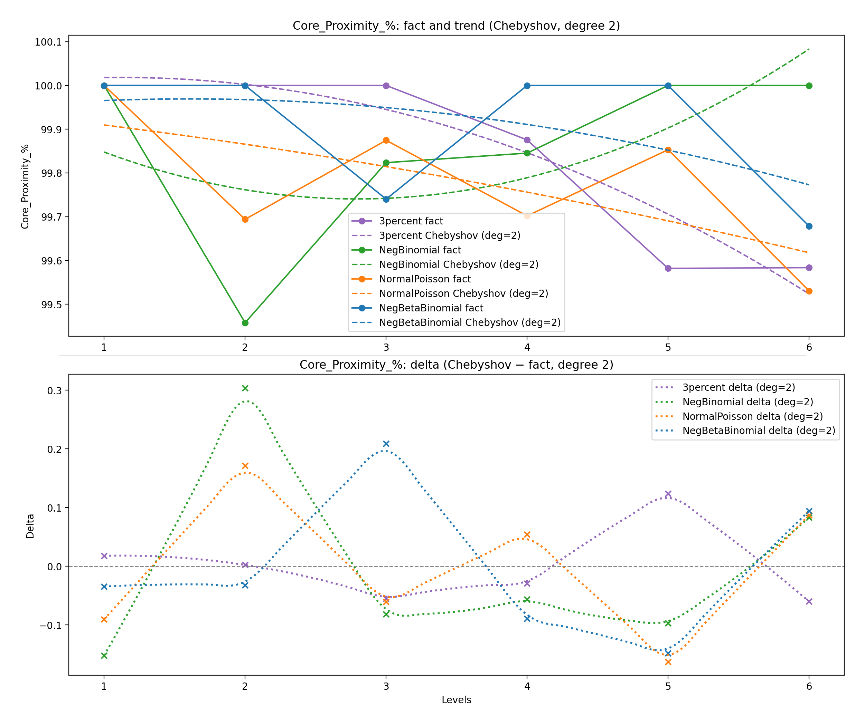
deltas_Diversity_two_panels_deg2.png
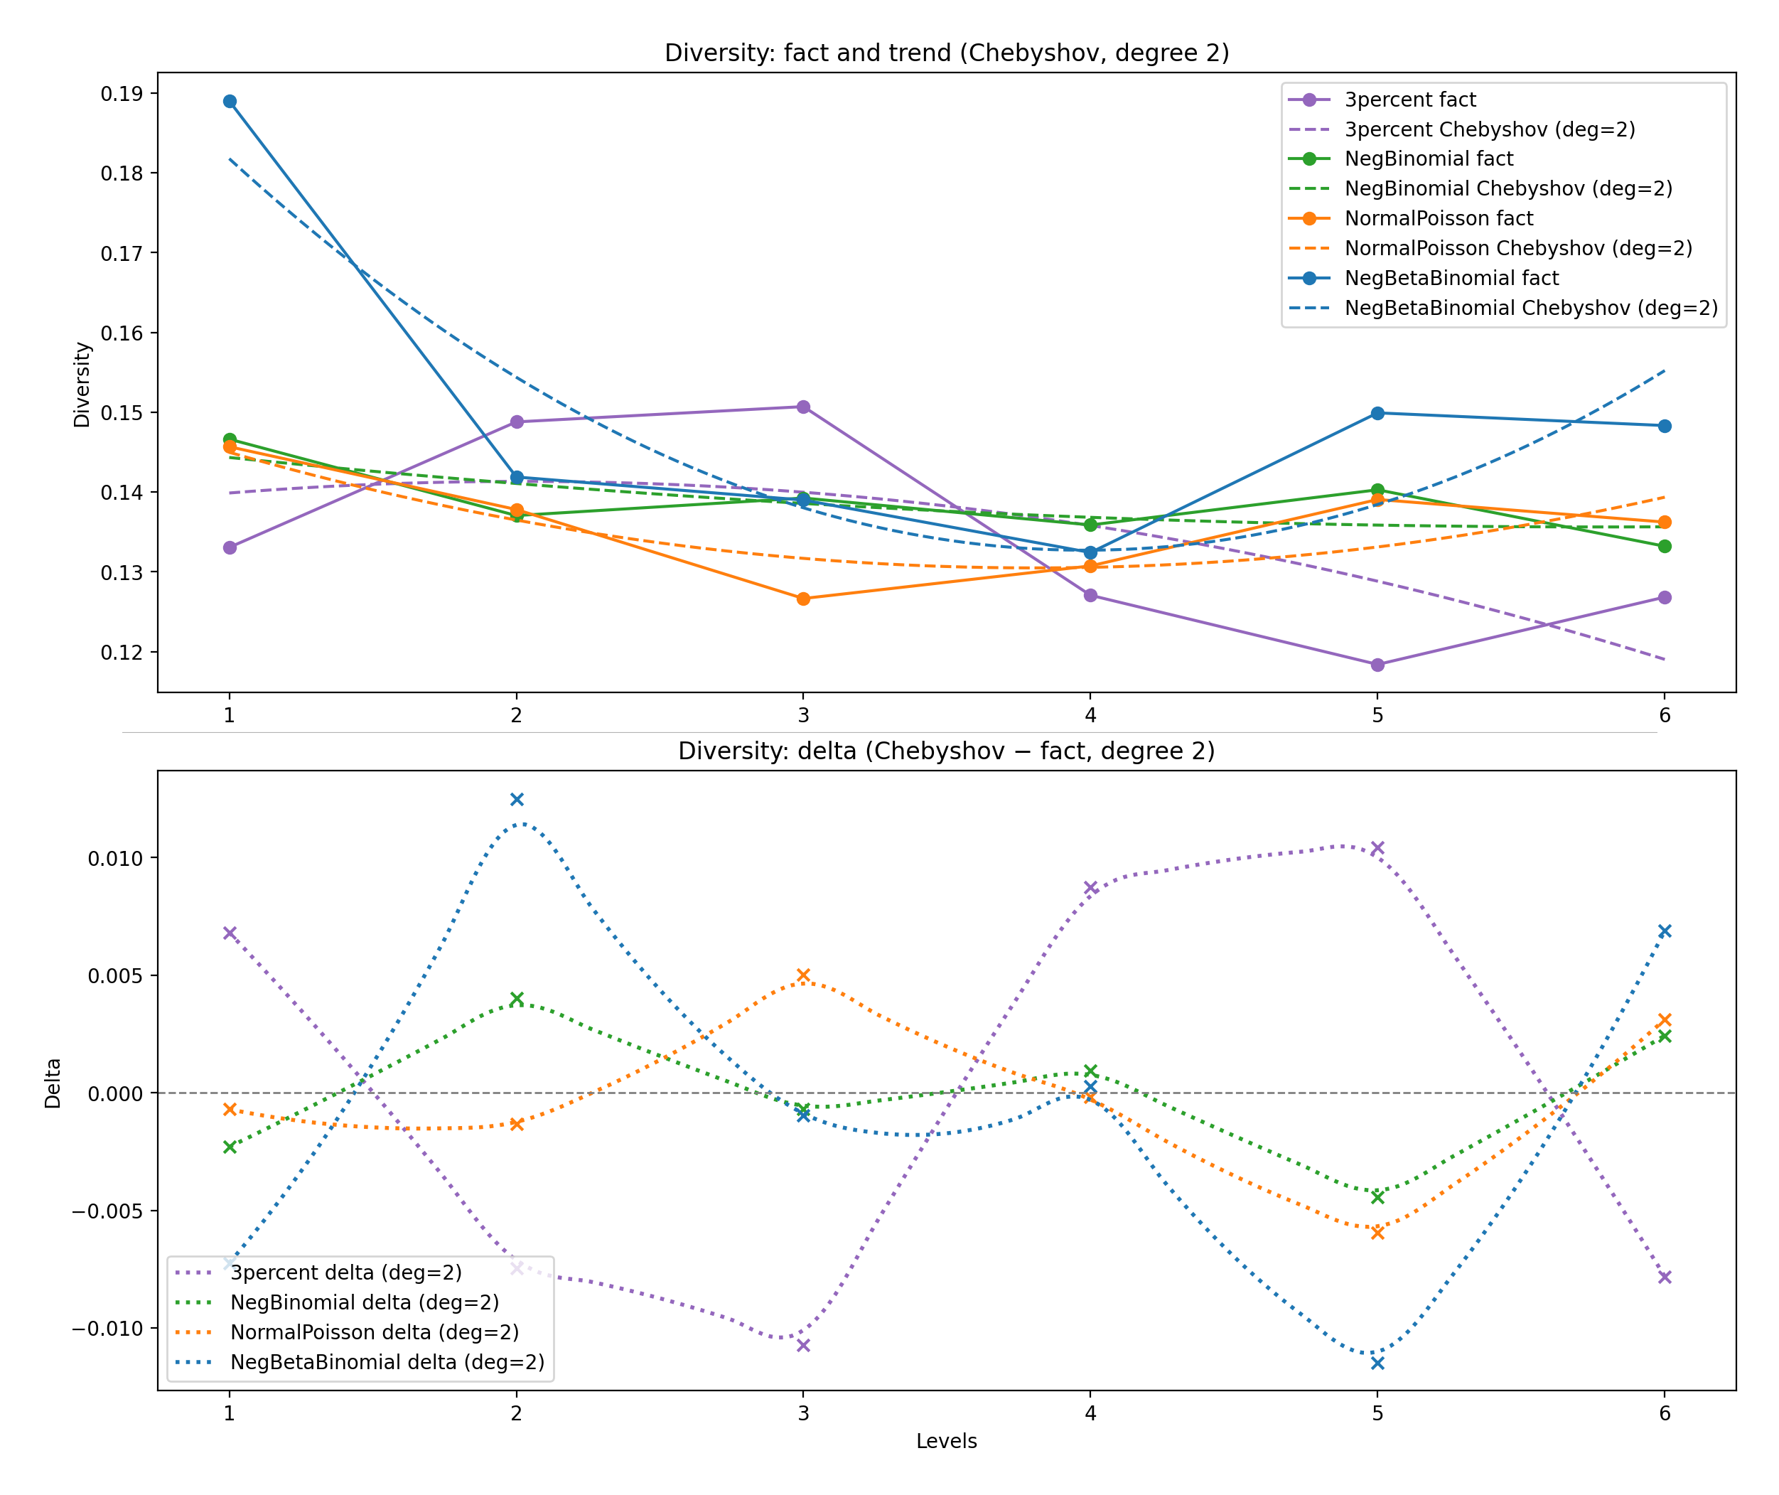
deltas_Topical_Diversity_Entropy_two_panels_deg2.png
